AN EXPOSURE-RESPONSE CURVE FOR COPPER
EXCESS AND DEFICIENCY

Running Title: Copper Exposure-Response

Andrea Chambersª, Daniel Krewski^{b}, Nicholas Birkett^{c}, Laura Plunkett^{d}, Richard Hertzberg^{e}, Ruth Danzeisen^{f}, Peter J. Aggett^{g}, Thomas Starr^{h}, Scott Baker^{i}, Michael Dourson^{j}, Paul Jones^{k}, Carl L. Keen^{l}, Bette Meek^{m}, Rita Schoeny^{n}, Wout Slobº,
ª McLaughlin Centre for Population Health Risk Assessment, Institute of Population Health, University of Ottawa, 1 Stewart Street, Ottawa, Ontario, K1N 6N5, Canada, FAX: 613-562-5380, PHONE: 613-562-5381, EMAIL: acham035@uottawa.ca
^{b} McLaughlin Centre for Population Health Risk Assessment, Institute of Population Health, University of Ottawa, 1 Stewart Street, Ottawa, Ontario, K1N 6N5, Canada, FAX: 613-562-5380, PHONE: 613-562-5381, EMAIL: dkrewski@uottawa.ca
^{c} McLaughlin Centre for Population Health Risk Assessment and Department of Epidemiology and Community Medicine, University of Ottawa, 451 Smyth Rd., Ottawa, Ontario, K1H 8M5, FAX: 613-562-5410, PHONE: 613-562-5410, EMAIL: nbirkett@uottawa.ca
^{d} Integrated Biostrategies LLC, EMAIL: lmplunckett@inbiostrat.com

^{e}Department of Environmental and Occupational Health, Emory University, 1518 Clifton Rd., Atlanta, GA 30322, EMAIL: rhertzb@sph.emory.edu

^{f} Assistant Director, Environment Program, International Copper Association, Ltd., 260 Madison Avenue
New York, NY 10016-2401 USA, PHONE: 212 251-7249, EMAIL: rdanzeisen@copper.org

^{g} Emeritus Professor, Littlefield, Parbold Hill, Parbold, WN8 7TG, United Kingdom, PHONE: +44(0) 1257 464276, EMAIL: profpjaggett@aol.com

^{h} TBS Associates, Raleigh, NC USA, PHONE: 919-876-0203, tbstarr@mindsping.com

^{i} Director, Environment Program, International Copper Association, 260 Madison Avenue 16th Floor
New York, NY 10016, United States, PHONE: 01-212-251-7240, sbaker@copper.org

^{j} Director, Toxicology Excellence for Risk Assessment, 2300 Montana Avenue, Suite 409, Cincinnati, Ohio 45211 USA, PHONE: 513 542 7475 ext. 14, EMAIL: dourson@tera.org

^{k} Waltham Center for Pet Nutrition, Waltham on the Wolds, Leicestershire, UK, LE144RT. EMAIL: Paul.jones@eu.effem.com

^{l} Department of Nutrition, University of California at Davis, EMAIL: clkeen@ucdavis.edu

^{m} McLaughlin Centre for Population Health Risk Assessment, University of Ottawa, 1 Stewart St., Ottawa ON, K1N6N5, PHONE: 613-562-5800 ext 2117, EMAIL: bmeek@uottawa.ca

^{n} US Environmental Protection Agency, EMAIL: schoeny.rita@epa.gov

^{n} Dutch National Institute for Public Health and the Environment (RIVM), EMAIL: Wout.Slob@rivm.nl

Abstract
There is a need to define exposure-response curves for both copper excess and deficiency to assist in defining the acceptable range of oral intake. A comprehensive database has been developed where different health outcomes from elevated and deficient copper intakes were assigned to an ordinal severity score to create a common measure of response. A generalized linear model for ordinal data was used to estimate the probability of response associated with dose, duration and severity. The model can account for differences in animal species, the exposure medium (drinking water and feed), age, sex, and solubility. Using this model to define the exposure-response curves for copper excess and copper deficiency, an optimal intake level of 2.6 mg Cu/day was defined. Integrating a broad range of responses of different levels of severity in the categorical regression analysis defines an extra risk concentration for copper deficiency that is higher than the current US recommended dietary intake (RDI; 0.9 mg/day) and an extra risk concentration for copper excess that is lower than the current tolerable upper intake level (UL; 10 mg/day). Compared to traditional risk assessment approaches, categorical regression can provide risk managers with more information including a range of intake levels associated with different levels of severity and probability of response. To weigh the relative harms of deficiency and excess, it is important that the results be interpreted along with the available information on the nature of the adverse health effects that were assigned to each severity score.

INTRODUCTION
Copper has vital physiological functions within the body; it serves as a functional component of numerous metalloenzymes, accepting and donating electrons and is an important structural component of select macromolecules (Stern et al., 2007; ICPS, 2002). The World Health Organization (WHO) categorizes a metal as essential when “absence or deficiency of the element from the diet produces either functional or structural abnormalities and that the abnormalities are related to, or a consequence of, specific biochemical changes that can be reversed by the presence of the essential metal (WHO, 1996).” Like all elements, too much copper can also lead to undesirable effects. The body is equipped with a complex regulatory system that works to maintain internal concentrations of copper within a homeostatic range; however, when these mechanisms are disrupted adverse health effects can occur (Aggett and Fairweather-Tait, 1998). Characterizing the exposure-response relationship is an important step in determining the upper and lower limits of the acceptable range of oral intake. As the shape of the exposure-response curve has not yet been characterized for copper and may differ between deficiency and excess, there remains some uncertainty with respect to what levels should be recommended to balance the risk of adverse health effects from both copper excess and deficiency (Food and Nutrition Board, 2001).
A recent review in the Journal of Toxicology and Environmental Health described possible exposure-response modeling strategies for copper (Stern et al., 2007). Benchmark dose (BMD) modeling is an example of one of the more sophisticated approaches that has been developed for dose-response assessment. The benchmark dose is a modeled point in the dose-response curve of an adverse effect corresponding to a predetermined increase in risk (in the range of 5-10%, adjusted for background response) when compared to controls (Stern et al., 2007). This is an empirical curve-fitting strategy that uses all the dose-response data at one time point and is able to demonstrate uncertainty in the estimate. Benchmark dose modeling cannot, however, take into account several adverse health effects that may occur simultaneously. Biologically based dose-response modeling quantifies biological mechanisms to determine the toxic effects of chemical agents and in the future, may serve as a potential alternative to the use of laboratory experiments. Biologically based dose-response models are of particular interest in the risk assessment of essential metallic elements, since different mechanisms may lead to adverse health outcomes from both states of excess and deficiency. In general there is a lack of understanding of the dynamic and kinetic properties of copper in animal and human tissues, which limits the application of biologically based exposure-response models. The review by Stern et al (2007) identified categorical regression as a potentially useful approach for modeling the exposure-response relationship of copper. Categorical regression involves the organization of qualitatively heterogeneous response data in the form of ordered categories of severity and the application of regression analysis to predict the probability that a particular severity category occurs as a function of one or more independent variables (i.e., concentration and duration of exposure). This modeling strategy can incorporate data for multiple endpoints from multiple studies of copper excess and deficiency (Stern et al., 2007).
In order to conduct exposure-response modeling (e.g., categorical regression analysis), the extensive data on copper excess and deficiency must first be organized into an exposure-response database (Krewski et al., 2010b). In May 2008, a workshop was held in Ottawa, Canada on the health risk assessment of select essential metals. The focus of the workshop was copper, zinc and manganese. This meeting provided an opportunity to discuss the limitations of modeling dose-response relationships for such essential elements that are expected to exhibit “U-shaped” exposure-response curves. One of the series of papers from the workshop discussed how a categorical regression analysis could be used to model the exposure-response relationship for copper excess and deficiency (Krewski et al., 2010a). The above paper also presented a preliminary analysis of a copper exposure-response database. The database, which only included data from studies published prior to 2002, was not sufficient to create an exposure-response model for copper deficiency and excess; however, it was proposed that were the database to be updated, with time would permit a more comprehensive analysis with finer stratification options. It was postulated that the resulting exposure-response model could then be used to guide the determination of an acceptable range of oral intake for copper. The copper exposure-response database has been updated and now includes studies published prior to 2002. The purpose of the current paper is to provide a brief review of current dietary reference values for copper; define the acceptable range of oral intake as described by the World Health Organization; present the results of the literature review update; and utilize the updated database to construct an exposure-response model for copper deficiency and excess.
Typical Exposures and Nutritional Reference Values for Copper
The third National Health and Nutrition Examination Survey (NHANES III) in the United States revealed that depending on the age range, the estimated mean copper intake from food is 1.54-1.70 mg/day (Standard Deviation (SD) +/- 0.05) for men and 1.13-1.18 mg/day (SD +/- 0.05) for women (Food and Nutrition Board, 2001). NHANES III also reported that approximately 15% of adults in the United States consume supplements containing copper (Food and Nutrition Board, 2001). While food accounts for the majority of human daily copper intake, drinking water can also be a significant source especially if there is high dissolution from copper pipes (NAS, 2000).
For adult men and women, the recommended dietary intake (RDI) is currently set at 0.9 mg Cu/day (Food and Nutrition Board, 2001). The RDI is defined as being equal to the estimated average requirement (EAR) plus twice the coefficient of variation (set at 15%) to cover the needs of 98% percent of individuals (the RDI is thus 130% of the EAR). In North America the EAR is the intake level for a nutrient at which the needs of 50% of the population will be met (Cockell et al., 2008). Data from three studies were used to set the EAR at 0.7 mg Cu/day (Turnlund et al., 1990; Milne et al., 1996; Turnlund et al., 1997). No single indicator was judged to be adequate for deriving the EAR for adults. A combination of indicators from these studies were used, including plasma copper, ceruloplasmin, erythrocyte superoxide dismutase activity (SOD), and platelet copper concentrations (Food and Nutrition Board, 2001). One study found that 0.4 mg Cu/day was not adequate to maintain levels of serum copper, ceruloplasmin and SOD activity in 8 of 11 young men (Turnlund et al., 1997). In the second study, 0.8 mg Cu/day did not result in a significant decline in serum copper, caeruloplasmin, or SOD activity (Turnlund et al., 1990). It was therefore decided that the copper intake needed to maintain copper status in half of the individuals in a group was more than 0.4 mg/day but less than 0.8 mg/day. The data from these two studies were then used to construct a linear model, which suggested that half of the male subjects would not maintain their copper status with a copper intake of 0.6 mg/day. The third study found that platelet copper concentration declined in 8 of 10 women given 0.6 mg/day, but increased with copper supplementation (Milne et al., 1996). As this study suggested that 0.6 mg/day may be a marginal intake level in over half the female population, an increment of 0.1 mg/day was added to cover the female population, resulting in an EAR of 0.7 mg Cu/day. The Food and Nutrition Board (FNB) comments on the fact that these indicators do not always reflect dietary intake and that they may be inadequate for the detection of marginal copper status (Food and Nutrition Board, 2001). For example, during pregnancy, two commonly used indicators, serum copper and ceruloplasmin, increase independent of diet. Similarly, as ceruloplasmin is an acute phase protein, both serum copper and ceruloplasmin often rise with numerous disease conditions (Food and Nutrition Board, 2001).
The U.S FNB (2001) have prescribed an upper safe limit (UL) of 10 mg Cu/day. The UL was based largely on a double-blind supplement study showing normal liver function in adults consuming 10 mg Cu/day (Pratt et al., 1985). In North America an uncertainty factor of 1 is used because the No Observed Adverse Effect Level (NOAEL) is considered to be safe for most of the population. However, in the European Union an uncertainty factor of 2 is used to account for the potential variability in a normal population. It is important to note that the UL for copper was largely based on liver toxicity endpoints, and it does not take into consideration less severe but clinically important responses.
Acceptable Range of Oral Intake
The acceptable range of oral intake (AROI) has been described by the World Health Organization (WHO) as a trough in the U-shaped exposure-response curve (IPCS, 2002). They conceptualize the lower limit of this range as equivalent to the RDI and the higher limit equivalent to the LBMD_{2.5} (lower confidence limit on the benchmark dose) (IPCS, 2002). Figure 1 provides a theoretical representation of the AROI (IPCS, 2002). Variability among individuals, characterized by the risk of toxicity from excess and the risk of toxicity from deficiency in Figure 1, can be due to differences in homeostasis, bioavailability, age-related factors, and dietary and nutrient interactions (IPCS, 2002). Figure 1 presents a U-shaped exposure-response curve. The acceptable range of oral intake (the width of the trough) will vary depending on the essential metallic element being considered.
METHODS
Literature Review and Severity Scoring Update
In 2010, Krewski et al. published the results of an analysis of the original copper exposure-response database that was based on studies published prior to 2002 (2010a). Due to the limited number of studies on humans that were suitable for an exposure-response analysis, the database and analysis included both human and animal models. This analysis concluded that there was a need for more exposure-response data in order to permit a more comprehensive categorical regression analysis that would account for greater variability in the copper database. Following this analysis, the copper database was updated to include citations published between January 2002 and December of 2008. The initial pool of relevant citations was identified from the Copper Research Information Flow database which contains an extensive and up to date collection of publications on copper as it relates to human health and the environment. The project uses several online databases (e.g., Chemical Abstracts, Toxline, Medline, Biosis, NTIS, EMBASE) and thousands of electronic journals. The Copper Research Information Flow project is based in the Department of Earth and Ocean Sciences at the University of British Columbia and is supported by the International Copper Association. The pool of relevant citations contained case studies, experimental studies, human health risk assessments, epidemiological studies, and occupation exposure studies.
After the pool of relevant studies on copper deficiency and excess were identified, a qualitative “binning exercise” was conducted to categorize each study based on its quality and usefulness for an exposure-response assessment. This process is described in more detail in Krewski et al (2010b). The scoring of the individual studies with respect to their quality is available upon request. A working group with expertise in biostatistics, nutritional sciences, toxicology, and molecular biology reviewed the studies that were identified and also developed a list of quality considerations for human and animal studies (Table 1) as well as a list of exclusion criteria (Table 2).
In order to define an exposure-response relationship that integrates multiple studies measuring outcomes in different target organs with varying levels of severity, a common response scale is required. Excess and deficient levels of copper can lead to a wide range of responses with varying degrees of severity depending on the dose and duration of exposure. Ordinal severity scores were defined to create a common measure of response. Once a pool of relevant studies was identified, the response data from the individual studies were assigned to severity scores. The original severity matrix for copper was guided by a detailed review of indicators of toxicity from excess and deficiency (Stern et al., 2007). Table 3 presents the updated severity matrix that was based on the most recent literature review. The lowest severity level (severity level 0) corresponds to no changes compared to controls; in essence severity level 0 is the NOEL. Severity level 1 is associated with adaptive responses with no evidence of copper deficiency or excess. Severity level 2 corresponds to early phenomena of copper imbalance (e.g., loss of copper dependent enzyme function). Severity level 3 corresponds to derangements of metabolic substrates that are influenced by copper metabolism (direct or indirect mechanisms). In the original severity matrix that was used in the initial 2010 paper, the highest severity score (i.e., severity level 4) was associated with reversible adverse effects, irreversible adverse effects and death. Severity level 4 now corresponds with changes that could be described as gross reversible toxic effects whereas severity level 5 has been added and corresponds to irreversible, gross toxic effects. Death was given its own category, severity level 6. The listed responses in Table 3 are cumulative: those effects listed in lower severity categories are presumed to also occur in the higher categories. All responses measured within each study in the copper exposure-response database were assigned a severity score. As most studies reported multiple responses to copper excess or deficiency, several severity scores might be associated with one exposure level; in these cases, the single severity score that corresponds to the most severe effect was selected to represent the exposure group.

The exposure-response data and the corresponding severity scores from the literature review update were added to the original copper database. This database was designed to hold all of the exposure-response data, the assigned severity scores and detailed information extracted from each study. Tables A1 and A2 in Appendix A present the exposures and assigned severity scores used in this analysis for copper excess and copper deficiency, respectively. Detailed information extracted from each study in the copper database is also presented including the animal species, exposure medium, copper species, age, sex, study design, and dose and duration of exposure. In the tables, reference identification numbers 1 to 106 are from the original literature search and numbers 107 to 211 reflect the new papers that were included in the database update.

Exposure-Response Analysis

Exposure-response data extracted from the studies identified in the literature review were assigned severity scores and were integrated into the copper exposure-response database. The severity scoring system utilized was described above. The resulting database was used to conduct the categorical regression analysis. Typically when data from multiple species is combined, dose is redefined by a concentration metric that will account for interspecies differences in sensitivity. The dose metric defined by mg/kg bw^{3/4}/day has been recommended as it seems to describe several physiological processes related to effective intake and internal dose (Rhomberg and Lewandowski 2006). For this analysis, dose was defined in mg/kg bw/day as the CatReg program can account for interspecies differences beyond body weight by allowing the user to define species specific model parameters. There are, however, advantages to defining a dose metric that accounts for interspecies differences in sensitivity. Any differences that can be reduced or eliminated by scaling will reduce the complexity of the model by eliminating the need to stratify model parameters by animal species. Future CatReg analyses with the copper database will explore alternative dose metrics that account for interspecies differences.
Compared to animal studies, human studies often provide more information on the total amount of copper consumed; however, experiments that control copper intake with the use of a capsule often do not provide accurate information of the amount of copper consumed in a basal diet. In such cases, information on typical dietary copper intakes can be estimated from studies that have measured habitual dietary intake (Baker et al., 1999a). While the concentration of copper in feed is often provided in studies on animals, there is often missing information on total feed intake. This information can be estimated from standard laboratory guidelines for experimental animal studies. A systematic process was developed to ensure that any assumptions used to estimate feed or water consumption levels or body weights were documented and standardized across studies (Chambers, 2009).

The categorical regression analysis presented in this paper used studies on humans, rats and mice. While studies with pig and rabbits were included in the database, such studies were omitted from the analysis due to their scarcity in the database. At this time the analysis focuses on subacute, subchronic and chronic exposure studies and defines duration in days. Acute exposure studies were not included in this analysis. In the preliminary analysis of the copper exposure-response database that contained studies published prior to 2002 (Krewski et al., 2010a), inclusion of the acute exposure studies in the analysis dramatically increased the magnitude of the standard errors. It also defined intercept parameter estimates for each severity score that were not significant and eliminated the effect of duration in the exposure-response model. In the exposure-response model for copper excess, as duration of exposure increased, so did the severity of response. Adding several observations that correspond to high levels of severity and short durations of exposure (i.e., exposure within one day or a onetime exposure) disrupted this pattern in the exposure-response curve. Acute exposure studies that have been included in the database typically administer high levels of copper in drinking water and make observations within one hour after the exposure. The experimental design and the outcomes of interest are very different from studies that have used subacute or subchronic exposures.

As there were no observations on copper deficiency that were assigned a severity level 5, scores 4-6 were combined in the copper deficiency exposure-response model. Due to the scarcity of observations within categories 5 and 6 for copper excess, scores 4-6 were also combined.
CatReg, a software program developed by the U.S. Environmental Protection Agency, was used to conduct the exposure-response analysis. Two analyses were conducted to define separate exposure-response curves for copper excess and deficiency. CatReg uses a generalized linear model (cf. McCullagh and Nelder, 1989) to describe the dependence of the probabilities of different severity categories occurrence on the explanatory variables, namely, the concentration and duration of exposure (US EPA, 2000). It is assumed that the response is related to the explanatory variables according to a user specified functional relationship called a link function. The use of a link function in CatReg has been described as “a function applied to the exposure-response curve to transform it to a simple linear relation in concentration and duration. By also transforming the observed responses, the link function reduces the mathematical complexity of estimating the parameters” (US EPA, 2000). For the three different probability functions that are available (logistic, normal, and Gumbel) there are three corresponding link functions (logit, probit, and cloglog). Further details on the use of the link functions can be found in the CatReg user manual (US EPA, 2000).
An important feature of CatReg is the ability to calculate the Effective Response Concentration (ERCq) for various severity levels from the exposure-response model. By fixing the duration of exposure, and defining a level of probability (e.g., ERC05, ERC10), the effective dose at different levels of severity can be estimated. We fixed the duration of exposure for ERCq curves at 100 days. A chronic duration of exposure would have been ideal; however, there are very limited data on humans after 100 days of exposure. It is also important to note that if the data were based on individual exposed subjects, the probability represents the chance that an individual’s responses will be at that level of severity or higher, or, for homogeneous populations, the expected fraction of the population predicted to exhibit response of a given severity level or higher. If the data are only available at the dose group level, which is the case in this analysis, an ERC10 estimate for a given severity category is the concentration associated with a 10% probability that a group exposed at that dose would be predicted to exhibit responses of that severity category or higher.
Two models are available in CatReg, a cumulative odds model and an unrestricted cumulative odds model. In the case of the cumulative odds model, the intercept parameters can differ by the severity level while the coefficients for concentration and duration do not differ by severity level. In the unrestricted cumulative model, the coefficients for the concentration and duration of exposure are estimated separately for each severity level (US EPA, 2000). The copper excess and deficiency data were modeled first with the unrestricted cumulative odds model followed by the restricted cumulative odds model. In CatReg the ‘parallel.test’ function was used to test the joint null hypothesis that the parameter estimates for concentration at each severity level and the parameter estimates for duration at each severity level are the same. The test is a generalized Wald-type chi-square test that all of the specified constraints hold. A p-value smaller than 0.05 was taken as evidence that the null hypothesis should be rejected and that rather the more complex model (i.e., unrestricted cumulative odds) be used.
To select the link function and the transformation options for concentration and duration, the Akaike information criteria (AIC) was used to compare 12 different models defined by three different link functions (logit, probit and complementry log-log) and four transformation options (logarithmic or linear concentration and/or duration dependence). The AIC selection is intended to select best modelled fit by balancing possible bias and variance in the model. The selection of the link function is a modeling decision that currently does not have a biological basis. The model with the lowest value for the AIC was thus selected for further analysis.
In the copper database, there are groups of observations from the same experiment and/or the same study. Ignoring the correlations within observations from these clusters could lead to estimated standard errors for the model parameters that are biased towards zero. CatReg provides an option for the user to specify whether or not the dataset contains any clusters and uses the method of generalized estimating equations to account for the cluster sampling effect (Simpson et al., 1996; Diggle, et al., 1994). In the current analysis, all observations from the same reference and experiment were treated as a cluster.
The effects of potentially important explanatory variables were assessed in CatReg by stratifying regression parameters according to the levels of these variables; variables included animal species, exposure medium (drinking water versus feed), age, sex, and copper solubility. It is important to note that copper is generally more bioavailable in water than in food. To account for the increased risk of toxicity from copper in drinking water, the exposure-response model for the copper excess data was stratified by the exposure medium (drinking water versus feed). However, the exposure-response model for copper deficiency was not stratified by the exposure medium. When copper is administered in drinking water in copper deficiency studies, the copper deficient groups are given purified drinking water and a diet containing only minimal amounts of the element. The control group is then typically given the same diet; however, the drinking water is supplemented with adequate amounts of copper to prevent any responses associated with copper excess or deficiency. Therefore, whether copper is administered in the drinking water or the diet of the control group should not impact the severity of response in copper deficiency studies.
In order to stratify the intercept, concentration and/or duration parameters by age, a two level categorical variable was defined (‘young’ and ‘mature’). Young rats and mice were less than or equal to 30 days of age and mature rats and mice were older than 30 days of age. These designations were based on age categories and life stage estimates from the Canadian Council on Animal Care (1984), which are based on the estimated age at puberty. At this time, the human studies in the database only focus on adults (≥ 18 years of age).
The effect of sex in the exposure-response model was evaluated. As there are studies in the copper exposure-response database that do not report results independently for males and females, a three level variable was created (‘both’, ‘males’ and ‘females’).
Copper salts that have low solubility include copper hydroxide, copper oxide and copper carbonate (Stern et al., 2007). Often copper salts with low solubility are used in copper deficiency studies to decrease the absorption of copper to increase the deficiency state. The majority of studies on copper excess utilize forms of copper with high solubility and very few studies use less soluble forms of copper. Therefore, the effect of solubility was only assessed in the exposure-response model of the copper deficiency data.
Stratification allows systematically different subsets of the data to have different values for some or all of the parameters including the models’ intercept, concentration or duration parameter (US EPA, 2000). Upon stratifying the model’s intercept, concentration and/or duration parameters, CatReg provides an option to test statistically whether the estimates produced for one variable (e.g., intercept coefficients for rats, mice and humans) are different from each other. The test is a generalized Wald-type chi-square test of the null hypothesis that there is a common set of model parameters across the strata.
Model selection was based on a series of likelihood ratio tests between nested models. The goal was to produce an exposure-response curve that sufficiently accounts for the variability in the data by considering different parameters and stratification options, but one that achieves this aim as simply as possible. If stratifying any of the model parameters decreased the model deviance by only a small amount, the simpler model was used. A likelihood ratio test for the significance of the more general model was computed by taking the difference between the deviances of the two models. The difference in the deviance was compared to a chi-square distribution with degrees of freedom equal to the differences in the number of parameters between the two models.
Observations that contribute to any lack of fit of the exposure-response curve can be identified by examining the individual contributions of each data point to the deviance. Data points identified as potential outliners were reviewed in terms of the corresponding study design and range of endpoints measured. CatReg was used to generate what the program refers to as ‘allsevsplots’, which plots the ERCq lines for each level of severity at a defined extra risk level (q) on one graph where the y axis is defined by concentration and the x axis by duration. These plots also present the data points corresponding to the defined stratum. These plots were used to look at the impact of duration in the exposure-response model. When there were no observations that corresponded to a particular severity score, the ERCq line was defined by using observations from other strata in the analysis. These plots can also demonstrate where the ERCq curves fall relative to their corresponding observations.
Thus far, we have assumed that response to copper excess and deficiency are similar across animal species if duration of exposure is measured in days. However, an exposure duration of 100 days could be considered either a subchronic or chronic exposure in an animal study, while it might be viewed as only a subacute exposure in a study on humans. For this reason, the modeling results were compared to those from an analysis where duration of exposure was expressed as a species-specific percent of lifespan. We were interested in whether redefining the duration variable had an impact on our final results which were defined by the ERC10-T100 for humans at severity level 2 or greater. The duration scale would be redefined to account for differences in lifespan among animal species if the difference in our final estimates was greater than 20%.
The purpose of defining a model with animal studies is to fill information gaps that exist among studies on humans. It is readily appreciated that experimental toxicity data is gathered more easily in animals than humans in part because of the unique ethical considerations associated with conduct of controlled human studies. As a result, it is not surprising that in the current copper database the studies with rats greatly outnumbered the studies with humans. To look at the impact of combining data from multiple animal species, three further models were defined. One model used only the human data, the second model used only the rat data and the last model used only the data on mice. The ERC10-T100 estimates produced from these three separate analyses were compared to the original analysis that incorporated all animal species.
Studies are beginning to provide more information about the exposure-response curves outside of the acceptable range of oral copper intake. The copper database could be updated periodically to improve the precision and accuracy of the exposure-response curves and further refine the model estimates of the boundaries on the homeostatic range. To look at how the most recent update has modified the risk estimates produced in the categorical regression analysis, we compared an analysis of the copper database prior to the update (studies up until 2002) with an analysis of the most recent copper database (studies up until 2008).

Final Estimates
After estimating parameters of the exposure-response models for copper excess and deficiency, one of the challenges was interpreting the results to define the AROI. The IPCS has defined the lower limit of the AROI as representing the RDI (2002). Unlike the RDI approach, which uses incidence data, the categorical regression uses group level data. As long as the mean response is significantly different from controls and the reviewers consider the change to be clinically significant, the entire dose-group is assigned a single severity score. The boundary of the homeostatic range or the AROI would thus fall between the NOAEL and the Adverse Effect Level (AEL). In our analysis, responses associated with a severity level 0 would lie below the NOEL, while detectable but non-adverse responses (i.e., no evidence of copper imbalance) would be associated with a severity level 1 (i.e, NOEL). The AEL would be represented by responses associated with severity level 2 or greater. The goal then would be to minimize the risk of responses associated with a severity level 2 or greater. It was expected that the exposure-response curves would cross due to the modeling process as the deficiency curve starts at a probability level of 1.0 for zero copper intake and descents monotonically toward zero as intake increases, while the excess curve starts at a probability level of zero for zero copper intake and ascends monotonically to 1 for infinite copper intake. The copper deficiency and excess data were modeled separately, each by a monotonically changing function. To create a U-shaped exposure-response curve, the probability of copper excess multiplied by the probability of copper deficiency can be subtracted from the probability of response for copper excess (T_{E}) added to the probability of response for copper deficiency (T_{D}) (Equation 1). The dose associated with the lowest level of probability on this U-shaped exposure-response curve represents the optimal intake level
P(T) = P(T_{E}) + P(T_{D}) – P (T_{ED}) Equation 1

Where P(T) represents the probability of a response from either excess or deficiency.

RESULTS

Literature Review Update

The original copper database contained 79 studies; 26 of those studies were on copper excess and 53 were on copper deficiency. After the search update, 16 studies on copper excess and 26 studies on copper deficiency were added to the database. More specifically, as an observation in a categorical regression analysis corresponds to a dose group used in one experiment, 56 observations were added to the original 187 for copper excess, and 74 observations were added to the original 140 for copper deficiency. Figures 2a-f presents plots that categorize observations by whether they were in the original database (studies up until 2002) or added during the database update. Plots are defined separately for both copper deficiency and excess and for each animal species (humans, rats, mice). Table 4 presents the number of observations by severity score and animal species. The bolded value is the number of observations added from the literature review update. The number in parentheses corresponds with the total number of observations.

For copper excess, there were eight observations, all in rats, associated with a severity level 1 (i.e., no evidence of copper imbalance). There were twelve observations, all in rats or mice, on copper excess at severity levels 5 or 6 (i.e., irreversible gross toxicity and death). Because our definition of the AROI falls between severity levels 1 and 2, an important contribution of the literature review update was the addition of four observations on humans that were assigned a severity level 2 (i.e., early phenomena of accumulated copper).

Overall, the majority of observations on copper deficiency from the literature update were classified into severity levels 1 through 3. Even after the literature review update, there were still only eleven observations assigned to higher levels of severity.
Human Studies
The following discussion focuses on the studies identified in the literature review update. Studies entered into the original database are described by Stern et al. (2007) and Krewski et al. (2010b). Several additional acute exposure studies have been added to the copper exposure-response database (Araya et al., 2003a; 2003b; 2003c; 2004). Araya et al. (2003a) has identified and confirmed an acute NOAEL (4 mg Cu/L) and a LOAEL (6 mg Cu/L) for copper in drinking water. One of the acute exposure studies identified in the literature review update measured a wide range of responses to marginally low and marginally high levels of copper; these included, serum and erythrocyte copper levels, peripheral mononuclear cell copper, serum ceruloplasmin, the non-ceruloplasmin bound copper fraction, superoxide dismutase activity, haemoglobin, mean corpuscular volume, serum ferritin, liver enzymes, and gastro intestinal symptoms (Araya et al., 2003c). However, other than gastro intestinal symptoms, no detectable changes were observed (Araya et al., 2003c). In terms of subacute and subchronic exposures, only two human dietary studies on the effects of copper excess were added to the copper exposure-response database. Turnlund’s study (2004) looked at graded levels of copper intake on indices of copper status, oxidant damage and immune function, whereas O’Connor’s study looked at mononuclear leukocyte DNA damage and indicators of liver function (O’Connor et al., 2003).

Two new human studies on copper deficiency were identified in the literature review update. One study by Davis and Johnson (2003) used a lower (more deficient) dose of copper than in previous studies to investigate the effects of low and adequate copper intake on copper nutriture and putative risk factors for colon cancer susceptibility in healthy men. Copper deficiency has been identified as a possible dietary factor that can increase the risk of colon cancer. While low dietary copper did not affect any haematological indicators of copper status, it did increase fecal free radical production and fecal water alkaline phosphatase activity, which are established risk factors for colon cancer. The second study added to the database (Harvey, et al., 2003) is also considered an important study as it assessed three levels of copper intake including a deficient, marginally deficient and adequate dose of copper.
Animal Studies
The majority of new studies on rats are within the range of concentrations addressed in studies prior to 2002; however, emerging studies appear to utilize more marginally deficient levels of copper (Goldschmith et al., 2005). Marginally deficient and excess levels of copper are more informative for defining the acceptable range of oral intake. For copper deficiency, the most important new studies on rats are those that examined graded levels of copper deficiency (Anderson et al., 2007; Falcone et al., 2005; Johnson et al., 2005; Li et al., 2005). The experiment conducted by Johnson et al. (2005) is particularly important as it assessed seven levels of copper intake, including five marginally deficient copper levels.
Only two copper deficiency studies on mice were added to the database, neither of which address marginal levels of copper deficiency nor utilize a duration of exposure that had not been previously addressed in earlier studies. Only two mouse studies on copper excess were added. Kvietkauskaite’s study (2004) on mice can be considered an important addition to the database as it utilized multiple levels of exposure and included a broad range of indicators of copper status including sensitive measures of copper toxicity (Kvietkauskaite et al., 2004). At this time, there are still very few observations for animal species other than rats and mice. Three pig studies and one rabbit study on copper excess were identified in the literature review update (Armstrong et al., 2004; Feng, et al., 2007; Alissa, et al., 2004; Davis, et al., 2002). There was also one study using Rhesus monkeys that examined the effects of chronic copper exposure during early life (Araya et al., 2005). This study was not added to the copper database as it provided insufficient information on average daily food intake.
Copper Excess and Deficiency Exposure-Response Model
A total of 208 observations on copper deficiency and 207 observations on copper excess were available for this analysis. In terms of the modeling options available, for copper excess, the model that was associated with the lowest AIC used the logit link function and took the logarithm (log10) of both concentration and duration (Table 5). Table 5 also presents the AIC for copper deficiency. The complementry log-log link function produces the lowest AIC value; however, this link function tends to be easier to overparameterize than the other link functions. This means that it cannot handle as many variables because of the simplicity of the log-log transformation and the linear relationship that results from the use of this function. When the model is further stratified using this link function, CatReg presents several error messages in the calculation of the model parameters. The program recommends the use of the logit or probit link function when the complementry log-log link function produces these errors messages; consequently, the copper deficiency model will use the logit link function and log transform dose and duration.
Analyses were run with both the parallel-constrained cumulative odds model and the more complex unrestricted cumulative odds model. Attempting to fit the unrestricted model to the copper excess data produced an error message in CatReg, requesting that the user simplify the model due to incorrectly ordered severity estimates. For example, the ordered severity constraint does not allow the estimated background risk (intercept coefficient) for a severity level 3 response to be greater than that for a severity level 1 response.
Incorrectly ordered severity parameter estimates indicates that there may be too many severity levels in the data (US EPA, 2000). A series of reduced severity score agglomerations were compared. Reducing the number of severity scores to three levels was the only combination that resulted in correctly ordered parameter estimates for the severity scores. Severity scores 0 and 1 were therefore combined to represent level 0; scores 2 to 4 were combined to represent level 1; and scores 5 and 6 were combined to represent level 2.
The test for the assumption of parallelism found no significant departures from equality of the coefficients for concentration and duration across the severity scores (p=0.2402). This suggests that it would be reasonable to use the simpler parallel-constrained cumulative odds model. Furthermore, when we continued to use the more complex unrestricted cumulative odds model, we could not obtain model fits while stratifying the model parameters on the other variables of interest (i.e., animal species, exposure medium, age or sex). Errors messages in CatReg indicated that too many parameters were being estimated for the amount of data available.
The unrestricted cumulative odds model of the copper deficiency data allowed for all five severity levels to be defined; however, this more complex model also did not permit any of the parameters to be stratified by the variables of interest (i.e., animal species, age, sex, and copper solubility).
The simpler cumulative odds model in which the parameter estimates for concentration and duration are constrained to be equal across all levels of severity was fit to the copper excess and deficiency data. For the copper excess data, a series of stratification options were compared where the intercept, concentration and/or duration parameters were stratified by animal species, exposure medium (drinking water versus diet), age, and sex. The final model was selected based on the simplest stratification scenario that produced the best fit to the data (i.e., the best fitting simple model); this model stratified the intercept by animal species and the exposure medium and stratified the concentration parameter by animal species and age. Stratifying the model parameters by sex or solubility did not improve the fit of the exposure-response curve.
Table 6 presents the results from a generalized Wald-type chi-square test of the null hypothesis that the parameter estimates that were permitted to differ by strata are in fact equal. Animal species, exposure medium and age all appear to be important explanatory variables in the exposure-response model for copper excess. For copper deficiency, a series of stratification options were also compared where the intercept, concentration and/or duration parameter were stratified by animal species, age, sex, and solubility. Similar to the selection of the model for copper excess, the final model was selected based on the simplest stratification scenario that produced the best fit to the data (i.e., best fitting simple model); this model stratified the intercept by animal species and age. Stratification by sex and solubility did not significantly improve the fit of the exposure-response model for copper deficiency. Table 6 also presents the results from a generalized Wald-type chi-square test of the null hypothesis that the parameter estimates that have been stratified in the copper deficiency model are equal.
Table 7 presents the parameter estimates in the cumulative odds model of the copper excess data where the intercept has been stratified by animal species and the exposure medium and the duration parameter has been stratified by animal species and age. Table 8 presents the same information for the cumulative odds model of copper deficiency that stratifies the intercept by animal species and age. It is important to note that for copper deficiency, the duration parameter does not have a significant effect in the exposure-response model (p=0.8095). However, while duration was not significant in the final model, it was retained in the analysis to plot ERC10 curves by concentration and duration. CatReg will not plot horizontal ERC10 lines that have no dependence of risk upon the duration of exposure.

The cumulative odds model of the copper deficiency data was used to plot ERC10 curves at each level of severity for humans (Figure 2a), mature rats and mice (Figures 2b, 2d), and young rats and mice (Figures 2c, 2e). These figures emphasize the minimal impact of duration in the exposure-response model for copper deficiency. It is evident that the ERC10 curves for severity levels 1 and 2 are often well beyond the range of the available data for the rat and mouse strata, whereas the ERC10 lines for severity levels 3 and 4 are often extrapolated well beyond the range of the available data for the human stratum.

While all of the human, rat and mouse observations are used to estimate the parameters for the exposure-response model and plot the ERC10 curves, only the observations corresponding to a given stratum specific ERC10 plot are depicted in each panel in Figure 2. As some strata will not have observations available at all severity scores, information from other strata is used to define these ERC10 curves. For example, for the human stratum, the ERC10 curve for severity level 4 is an extrapolation entirely outside the range of the available data, as there are no severity level 4 observations in this human stratum. Indeed, only the young rat stratum has observations at all levels of severity. Figure 3 presents a similar series of plots for the cumulative odds model of the copper excess data. As might be expected, the parallel ERC10 curves in all of the strata have negative slopes, i.e., lower concentration is required to achieve the estimated 10% response probability at longer exposure durations.

To get an idea of how much variation in the response is accounted for by the explanatory variables, CatReg was used to generate generalized R² statistics. The total deviance that is explained by the model is 38.3% and 45.9% for the copper deficiency model and the copper excess model, respectively. One approach to qualitatively assess model fit is to check whether the ERC10 curve for each severity level is below (copper excess) or above (copper deficiency) the majority of its corresponding observations. For the series of plots of the copper excess data (Figure 3), all ERC10 lines for severity levels 1 to 4 are below the majority of their corresponding observations. For the series of plots of the copper deficiency data (Figure 2), the ERC10 curves for severity levels 1 to 4 also fall above the majority of their corresponding observations.

The cumulative odds models of the copper excess and the copper deficiency data were used to produce ERC10 estimates for severity level 2 or greater for each stratum (Table 9). After accounting for interspecies differences in body weight, the ERC10-T100 estimates for dietary studies on copper deficiency are 8.3 times greater for rats than humans and 18.2 times greater for mice than humans. The ERC10-T100 estimates for dietary studies on copper excess are 50.2 times greater for rats than humans and 823.8 times greater for mice than humans. The estimates can also be compared based on the exposure medium. Less copper is required to produce the same level of severity when consumed in drinking water than in the diet. The ERC10-T100 at severity level 2 or greater for human dietary studies is 0.05 mg/kg bw/day (90% CI 0.03, 0.08) and for human drinking water studies 0.03 mg/kg bw/day (90% CI 0.02, 0.05).

Sensitivity Analysis
No modifications were made to the duration variable to account for interspecies differences in physiologic time. Figures 5a and 5b present plots of the copper deficiency and copper excess data respectively where duration was defined in percent lifespan and dose in mg/kg bw/day. These figures highlight the lack of human subchronic and chronic exposure studies. Human data tend to cluster primarily between durations of 0 to 50% lifespan. In terms of the ERC10 estimates for humans for severity level 2 or greater, when percent lifespan is incorporated into the model, the original human ERC10 value for copper deficiency increases from 0.031 (90% CI 0.022, 0.045) to 0.032 (90% CI 0.022, 0.045), a percent change of less than 3.1%. For copper excess, the original ERC10 value decreases from 0.047 mg/kg bw/day (90% CI 0.028, 0.078) to 0.045 (90% CI 0.027, 0.075), a percent change of less than 4.3%. The results are relatively stable when the duration variable in the model is adjusted to account for interspecies differences in lifespan.
To investigate the impact of combining studies with different animal species in a common analysis, a separate species-specific analysis was conducted. Table 10 presents the ERC10 estimates for severity level 2 or greater for each animal species in a species-specific analysis as well as a combined analysis for copper excess. Table 11 presents the same information for copper deficiency. For copper excess there was insufficient human data to run a model with 5 levels of severity (severity level 0 to severity level 4). In order to run the model we had to combine severity levels 1 and 2 as well as severity levels 3 and 4. For both copper deficiency and excess, there was insufficient data on mice to run the analysis. Overall the ERC10 estimates produced in the species specific analysis are close to the ERC10 estimate generated in the combined analysis (Table 10 and 11). Comparing the combined analysis to the species-specific analysis for copper excess, the ERC10 estimates for rats increased from 2.51 mg/kg bw/day (95% CI 1.20, 5.25) to 3.56 mg/kg bw/day (95% CI 1.53, 8.28) and the ERC10 estimates for humans decreased from 0.05 mg/kg bw/day (95% CI 0.03, 0.08) to 0.04 mg/kg bw/day (95% CI 0.01, 0.21). For copper deficiency, the ERC10 estimates for rats decreased from 0.25 mg/kg bw/day (95% CI 0.15, 0.42) to 0.24 mg/kg bw/day (95% CI 0.13, 0.42) and the ERC10 estimates for humans decreased from 0.03 mg/kg bw/day (95% CI 0.02, 0.05) to 0.02 mg/kg bw/day (95% CI 0.01, 0.02). Compared to the combined analysis, the species-specific analyses also appear to be associated with wider confidence intervals. Allowing the analysis to incorporate data from all three species provides more precise estimates.
Prior to the database update, there were 136 observations and 187 observations from copper deficiency and excess studies, respectively. After the copper database update, 73 observations were added for copper deficiency and 55 observations were added for copper excess. There was only a small change in the estimate for copper deficiency since the database update (Table 12). The ERC10-T100 estimate for severity level 2 or greater before the update was 0.032 mg/kg bw/day (90% CI 0.021, 0.049 mg/kg bw/day) which decreased slightly to 0.031 mg/kg bw/day (90% CI 0.022, 0.045 mg kg bw/day) after the update. There was a larger change in the estimates for copper excess. The ERC10 for severity level 2 or greater before the update was 0.076 mg/kg bw/day (90% CI 0.038, 0.152 mg/kg bw/day) which decreased to 0.047 mg/kg bw/day (0.028, 0.078 mg/kg bw/day) after the literature review update. Consequently, the database update ended up narrowing the acceptable range of oral copper intake defined by the ERC10 estimates for severity level 2 or greater.
Based on the various results from sensitivity analyses, the final copper deficiency and excess models utilized exposure duration expressed in days and all of the available data on humans, rats and mice in a combined analysis. The cumulative odds models defined by these specifications produced an ERC10-T100 estimate at 2.2 mg/day (90% CI ) for severity level 2 or greater for copper deficiency and 3.3 mg/day (90% CI ) for severity level 2 or greater for copper excess. Figure 6a-d, presents the plots of the probability curves for severity levels 1 to 3 for both copper deficiency and copper excess. Equation 1 was used to create a summative U-shaped exposure-response curve (represented by the dotted curves in Figures 6b-d). The resulting trough in the U-shaped curve or the AROI is quite narrow. At the lowest level in the U-shaped curve for severity level 2 or greater (p=0.1080), the corresponding dose is equal to 2.6 mg/day. Therefore, the optimal intake level to protect the population from severity level 2 or greater responses associated with both copper deficiency and excess is approximately 2.6 mg/day. The optimal intake level to protect the population from severity level 3 or greater responses associated with both copper deficiency and excess is approximately 2.2 mg/day. It is important to note because group data, and not individual subject data, were used in this analysis, it complicates the interpretation of the final risk estimates. If the data were for individual exposed subjects, then probability curves would represent estimates of individual risk. However, with data only available at the group level, as is the case in this analysis, then p would represent the probability that a group of the average size of groups in the copper database would exhibit a mean response of a given severity level or greater. Essentially the CatReg model is predicting a 11% probability that a response of category 2 severity or greater, from either excess or deficiency, will occur and be detected reliably if that dose is given to a group of subjects (of the average group size in the copper database) for 100 days.

DISCUSSION
This study has illustrated how categorical regression, which combines data from different sources and uses a common severity scale, can be used as an analytical approach to critically evaluate data on copper excess and deficiency and define a range of dietary intakes that will meet the nutritional requirements of a healthy population as well as avoid adverse health effects from elevated copper intake. As illustrated in the analysis, considerable variability in the copper exposure-response database in terms of the study design, animal species, sex, and age could be accounted for by stratifying parameters in the exposure-response model. The analysis of the copper database has estimated an optimal intake level of 2.6 mg/day for severity level 2 or greater.
Stratification Options
Animal Species: Animal species had an important effect in the exposure-response models for both copper excess and deficiency. The stratum specific ERC10-T100 estimates defined by the model of the copper excess data demonstrate that compared to humans, rats and mice seem to be less sensitive to adverse health effects when dose is expressed in mg/kg bw/day. Smaller differences were found for copper deficiency. It is important to note that the differences in the ERC10 estimates observed among animal species can also be a result of differences in the design of studies on animals versus humans and differences in the types of responses under investigation.
Duration: For humans, generalizations regarding the impact of duration of exposure from subchronic and chronic exposures cannot be made at this time due to a lack of data past 100 days of exposure. For rats and mice, duration does seem to have an important impact on the exposure-response curve for copper excess, as a lower ERC10 is required to produce the same response probability as duration increases. With the data set currently available, duration seems to have minimal effects on the exposure-response curve for the copper deficiency data. Intuitively, one would predict that duration should have an effect. We recognize that if there were more chronic studies, there might be sufficient power to detect an impact of duration. It is important to note that the impact of duration will be modulated by the growth stage of the animal. If the animal is in a period of rapid growth, tissue copper concentrations will drop more precipitously than they will in the adult as a consequence of growth-associated expansion of tissue mass.
Exposure Medium: The exposure medium (drinking water versus feed) had a significant effect in the exposure-response model of the copper excess data. A lower dose was required to produce the same level of severity when copper was administered in drinking water compared to copper administered in feed or a capsule. At this time, there is a lack of human data documenting any negative effects due to chronic intake of high amounts of copper in drinking water. Additional research on the effects of chronic intake of copper in drinking water is needed as there have been some concerns raised about the potential long-term health effects of high levels of copper in drinking water.
A difficulty with the data extracted from existing human drinking water studies is that there are currently no observations that were classified into severity levels 1 to 3. Human studies that have looked for adverse health effects from copper excess have either found no effects (severity level 0) or responses that have been classified as severity level 4. For humans, the impact of the exposure medium on the risk of adverse health effects from elevated copper intake cannot be adequately assessed at this time. More research is required to better understand the potential importance of copper obtained through drinking water with respect to copper balance and long-term health. Such studies should ideally include a broad range of sensitive markers of copper imbalance (e.g., markers of immune system dysfunction) and use a chronic duration of exposure.
Compared to studies on humans, there are a greater number of rat and mouse studies that have evaluated the effects of subacute and subchronic exposures to excess copper in drinking water. These studies have measured a broad range of sensitive markers of copper toxicity. The data suggests that there is greater sensitivity to copper excess when copper is administered in drinking water, compared to the same dose administered in diet.
Age: For copper deficiency, there was a small difference in the ERC10 estimates between young and mature rats and mice. The differences were 0.36 mg/kg bw/day and 0.93 mg/kg bw/day for rats and mice, respectively. The difference was more pronounced for copper excess, where weanling rats and mice were obviously more sensitive than mature rats and mice. The differences were 41.19 mg/kg bw/day and 29.51 mg/kg bw/day for rats and mice, respectively. These results are consistent with other findings showing that young rats absorb copper in a concentration-dependent fashion with limited feedback control or saturability (Coudray et al., 2006; Varada et al., 1993).
Sex: Sex did not have a significant effect in either the cumulative odds models for copper excess or that for deficiency. For humans, this is consistent with the finding that, on a body-weight basis, men and women have similar copper requirements (Johnson et al., 1992). In animal studies, however, differences have been observed between males and females (Shiraishi et al., 1993; Nederbragt, 1985; Fuentealba et al., 2000; Linder et al., 1979; Bremner et al., 1981; Bureau et al., 2003; Farquharson et al., 1988). More studies are needed wherein both males and females are exposed to excess and deficient levels of copper and where the results are reported separately by sex.
The lack of a significant effect of sex in the exposure response-model could be due to inconsistencies found in the literature. In some studies males appear to be more sensitive to copper toxicity (Shiraishi et al., 1993; Nederbragt, 1985) whereas in other studies females appear to be more sensitive (Fuentealba et al., 2000; Linder et al., 1979; Bremner et al., 1981; Bureau et al., 2003; Farguharson et al., 1988). Although it has been suggested that the impact of sex on liver copper accumulation in rats depends on the strain used (Fuetealba et al., 2000), the current exposure-response models are not able to take into consideration the animal strain. Furthermore, the impact of sex has been shown to vary depending on the target organ of observed toxicity. At this time, there are insufficient data available to incorporate target organ and animal strain in the exposure-response model.
Comparison of Results with Current Regulatory Values

The optimal (minimum risk) intake level for severity level 2 has been estimated to be approximately 2.6 mg Cu/day. In the United States and Canada, the current recommendations for copper intake among adults range from 0.9 mg Cu/day (RDI) to 10 mg Cu/day (tolerable UL). The optimal (minimum risk intake level for severity level 2 or greater (2.6 mg/day) is below the tolerable UL for copper (10 mg Cu/day) established by the Food and Nutrition Board (2001). One of the issues with the current upper intake level is that it is based solely on the NOAEL for markers of liver function identified in a single study (Pratt et al., 1985). If for every study in the copper database (which considers a broad range of markers of copper excess and deficiency) we had applied a traditional risk assessment approach where a NOAEL identified from a single study is divided by an uncertainty factor, we would likely end up with a reference dose that is more similar to the results generated in the categorical regression. This would be due to the fact that the studies in the copper database consider less severe but still clinically important responses to elevated copper intake, whereas the tolerable UL is based exclusively on liver toxicity.
The current RDI for copper is 0.9 mg/day. There are several reasons why the optimum dose that minimizes the risk of severity level 2 or greater responses to deficiency or excess is higher than the current RDI for copper. The categorical regression approach takes into consideration more studies on copper deficiency, beyond the three studies used to set the EAR. The copper database contains several studies that have found responses associated with severity level 2 or greater that are relatively close to the current RDI (0.9 mg Cu/day). For example, in the study by Klevay et al. (1986), 0.8 mg Cu/day for 150 days was associated with severity level 3 responses, namely increased plasma glucose levels and decreased insulin response, as compared to controls.
Limitations in the Analysis
It is important to recognize the various limitations of the categorical regression analysis. First, the quality of the final model parameter estimates is influenced by the quality of the data coming from the individual studies in the copper exposure-response database. All studies on rats and mice, and a few studies on humans employed a controlled experimental design. When deciding on which studies to include in the copper database, the original group of experts in toxicology and risk assessment not only assessed the utility of each experiment for an exposure-response analysis but also the scientific quality of the study (Krewski et al., 2010b). While controlled experimental designs are considered to be the most rigorous of the research design methods, alternative study designs were considered due to the limited data that were available across a wide range of doses and durations of exposure, especially among human studies. For example, two case studies were included in the copper database, one involving an acute and accidental overdose of copper, and one involving a report of cirrhosis from a chronic exposure to 45 mg Cu/day in supplement form. Case reports involving only a single individual clearly have limited generalizability; however, they are the only studies available showing the potential effects of long-term elevated copper intake or short-term effects of massive copper ingestion in humans.
It is important to consider the extent to which dose-spacing in the relevant studies impacted the results. The database contains a significant amount of exposure-response data that is derived from the control groups within an experimental study. These observations correspond to habitual intakes of copper that would typically be consumed in a regular diet. There is also a significant amount of data from animal studies at more extreme levels of exposure. When data clusters at very low and high levels of exposure, this does not result in optimal conditions to characterize the slopes of the exposure-response curve around the margins of the acceptable range of oral intake. Dose-spacing creates more uncertainty around the exposure response curves for lower levels of severity.
There was considerable effort required to construct the comprehensive copper database for the purposes of this analysis. Classifying responses into severity categories is a challenging task and requires considerable expert judgment. A number of studies measured a wide range of responses, and reported small but statistically significant differences compared to controls. A key challenge is deciding whether statistically significant differences are also clinically significant. The physiologic implications of the observed changes are not always known.
We have not described a formal test of validity; however, we recognize that the validity of our results is highly dependent on the validity of our model. One type of validation that we didn’t address was a form of direct structure test which would have involved comparing the model structure with information obtained directly from the real biological system being modeled (copper physiology) (Barlas, 1996). There are many gaps in our knowledge about the dynamic and kinetic properties of copper in animal and human tissues, which has limited the application of biologically based exposure-response models (Stern et al., 2007). An important question is whether we could actually define a more complex empirical model that took into consideration more detailed information about the real biological system with the exposure-response data that is available in our database. There were several limitations in the data that prevented the use of more sophisticated modeling approaches. The current model defined in CatReg is recognized as overly simplistic. However, what we have seen in the analysis is that when we try to increase the complexity of our empirical model, we do not have sufficient data to support it. This led to errors when attempting to run the unrestricted cumulative model which did not assume that ERC10 curves were parallel across severity scores. When there are limited data across different severity levels and ranges of exposure, model selection options become limited, which results in the use of simpler models and stricter assumptions. While the CatReg models allowed parameters to be stratified, essentially the process is a large meta-analysis of studies with disparate health end points, biological systems, and study designs. This requires the use of a complex model with several levels of stratification to sufficiently account for the variability in the database.
Empirical modeling approaches use mathematical models to fit data, often with little or no biological rationale. Because there are substantial data gaps in the current exposure-response database, the interpretation of results should be limited to the range of available data. For example, we should not use ERC10 estimates at chronic exposure durations for humans because there are minimal human data past 100 days of exposure. As we extrapolate beyond the available data, the extrapolations become more and more model dependent. Because data from multiple studies and multiple species can be combined in a common categorical regression analysis, extrapolations of model results might be regarded more defensible than those that could be made from Benchmark Dose analyses of data from single studies; however, there is no clear evidence that this is the case.
The lack of data available in the copper database forced some extrapolations. For example, exposure-response curves for higher levels of severity for the human data were estimated from exposure-response data from lower levels of severity. More questionable, perhaps, was the use of short-term data to estimate exposure-response relationships for subchronic exposure situations. Most importantly, the sparseness of chronic data precluded characterization of the acceptable chronic exposure range suitable for use in regulatory decision-making.

Future Research Initiatives
In order to improve the analysis and establish more confidence in the results, there is a need for more studies on humans investigating the effects of marginally excess and deficient levels of copper, and a need for the measurement of a broad range of relevant and sensitive markers of disrupted copper homeostasis. At this time, there is also a lack of information on the long term effects in humans of elevated or deficient copper intake. While a categorical regression analysis has been shown to be a useful empirical approach for modeling a diverse collection of studies on copper deficiency and excess, Stern et al. (2007) comments: “ideally, detailed information regarding copper uptake, binding, distribution, metabolism, and excretion would be coupled with mechanistic models of how various organ systems respond to variation in their copper status.” An improved understanding of copper metabolism is also needed to derive more precise estimates of dietary requirements. As more data are added to the copper database, there may be the potential for the development of organ-specific exposure-response models.
Future initiatives with the copper database could also involve a focused literature review update to identify and incorporate studies that have used subjects with perturbed copper metabolism (e.g., mutant mice) to evaluate potential differences in risk to excess and deficient levels of copper. There have been studies on rodent groups with some form of genetic abnormality which increases their sensitivity to the effects of copper imbalances (Sparks et al., 2006). Data from these types of experiments have not been included in the current database. Therefore, current estimates may not be applicable to those with genetic abnormalities in copper metabolism. It is recognized that in the human population, similar to all other species studied to date, there can be considerable variation in genetic predispositions to copper excess and deficiency (Stern et al., 2007). Further updates of the copper database might consider the inclusion of data from studies using transgenic or knockout rats and mice. This information would be useful for understanding mode of action and incorporating more biologically based considerations in dose-response analyses. The copper database also does not include experiments on pregnant animals. At this time, there is insufficient information to define an acceptable range of oral intake for pregnant women; however, including available developmental data study may allow us to explore differences in the risk estimates among pregnant rats and mice.
It is important to recognize that the current copper database includes only experiments wherein copper has been assessed alone, without any other dietary modifications. Several experiments have used both copper and zinc to explore the impact of the dietary interaction between these essential elements. Intakes of high amounts of dietary zinc can result in a reduction in copper absorption from the gut, and precipitate signs of copper deficiency (Stern et al., 2007). Recently, it has been suggested that zinc-induced copper deficiencies can also be a consequence of the excess use of denture creams high in zinc (Nations et al., 2008). Updating the copper database to include experiments (animal as well as human) that considered zinc-copper interactions would be of value in exploring the impact of the zinc-copper interactions on the magnitude of risk estimates that have been produced with the categorical regression analysis. Copper absorption has also been reported to be influenced by other dietary factors including iron and fructose (Uriu-Adams et al., 2010). The relative public health importance of these factors remains to be determined.
Further initiatives could also focus on improving the statistical models used to conduct exposure-response analyses. The current models available in CatReg can only define the exposure-response curves for copper deficiency and copper excess separately. Before developing a statistical technique that can incorporate copper deficiency and excess data in a combined analysis, there is a need to consider whether mechanisms of toxicity due to copper deficiency and excess are independent or interrelated at the biological level (Stern et al., 2007).
CONCLUSION
An expert panel from multiple scientific disciplines has developed a severity scoring system and a copper exposure-response database. A categorical regression analysis was undertaken to optimize the use of the available data on the adverse health effects from excess and deficiency. Study design, animal species, sex, and age were considered by stratifying parameters in the exposure-response models. The exposure-response models for copper deficiency and excess at severity level 2 define an optimal intake level at 2.6 mg Cu/day. Integration of a broad range of responses of different levels of severity in the categorical regression analysis produced an AROI that is much narrower than current recommendations for copper intake including the RDI (0.9 mg/day) and the tolerable UL (10 mg/day).
To weigh the relative harm of deficiency and excess, it is important that the results be interpreted within the context of the information available on the adverse health effects assigned to each severity score. While a biologically based exposure-response model for copper would be ideal, the data required to support such a model are currently unavailable. With that said, recommendations that minimize the general public’s risk for copper deficiencies as well as copper excess are needed.
This application of categorical regression to develop exposure-response curves for copper represents an attempt to initiate a common risk assessment approach that considers the risks of both deficient and excess levels of copper intake. As categorical regression is able to incorporate a broad range of responses to copper excess and deficiency, it offers a way to make more efficient use of the available data when making risk management decisions. Categorical regression may also be a useful empirical modeling approach that can be used to define exposure-response curves for other micronutrient requirements where a suitable body of data exists.

Disclaimers:

REFERENCES
Aggett, P.J., Fairweather-Tait, S. 1998. Adaptation to high and low copper intakes: its relevance to estimated safe and adequate daily dietary intakes. Am. J. Clin. Nutr. 67:1061S-1063S.
Ajayi, O.B. 2005. Micronutrient changes in some tissues of copper deficient rats. Pakistan J. Nutr. 4:123-125.
Alissa, E.M., Bahijri, S.M., Lamb, D.J., Ferns, G.A.A. 2004. The effects of co-administration of dietary copper and zinc supplements on atherosclerosis, antioxidant enzymes and indices of lipid peroxidation in the cholesterol-fed rabbit. Int. J. Exp. Path. 85:265-275.
Allen, C.B. 1996. Effects of dietary copper deficiency on relative food intake and growth efficiency in rats. Physiol. Behav. 59:247-253.
Allen, K.G.D., Arthur, J.R., Morrice, P.C., Nicol, F., Mills, C.F. 1988. Copper deficiency and tissue glutathione concentration in the rat. Proc. Soc. Exp. Biol. Med. 187:38-43.
Allen, K.G.D. Klevay, L.M. 1978. Copper deficiency and cholesterol metabolism in the rat. Atherosclerosis, 31:259-271.
Andersen, H.S., Gambling, L., Holtrop, G. McArdle, H.J. 2007. Effect of dietary copper deficiency on iron metabolism in the pregnant rat. Br. J. Nutr. 97:239-246.
Araya, M., Chen, B., Klevay, L.M., Strain, J.J., Johnson, L., Robson, P., et al. 2003a. Confirmation of an acute no-observed-adverse-effect level (NOAEL) and low-observed-adverse-effect level (LOAEL) for copper in bottled drinking water in a multi-site international study. Regul. Toxicol. Pharmacol. 38:389-399.
Araya, M., Kelleher, S.L., Arredondo, M.A., Sierralta, W., Vial, M.T. Uauy, R. 2005. Effects of chronic copper exposure during early life in rhesus monkeys. Am. J. Clin. Nutr. 2005. 81:1065-1071.
Araya, M., McGoldrick, M.C., Klevay, L.M., Strain, J.J., Robson, P., Nielsen, F., et al. 2001. Determination of an acute no-observed-adverse-effect level (NOAEL) for copper in water. Reg. Toxicol. Pharmacol. 34:137-145.
Araya, M., Olivares, M., Pizarro, F. González, M., Speisky, H., Uauy, R. et. al. 2003c. Gastrointestinal symptoms and blood indicators of copper load in apparently healthy adults undergoing controlled copper exposure. Am. J. Clin. Nutr. 77:646-650.
Araya, M., Olivares, M., Pizarro, F., Llanos, A., Figueroa, G. Uauy, R. 2004. Community-based randomized double-blind study of gastrointestinal effects and copper exposure in drinking water. Environ. Health. Perspect. 112:1068-1073.
Araya, A., Pena, C., Pizarro, F., Olivares, M. 2003b. Gastric response to acute copper exposure. Sci. Total. Environ. 303:253-257.
Arce, D.S., Keen, C.L. 1992. Reversible and persistent consequences of copper deficiency in developing mice. Reprod. Toxicol. 6:211-221.
Armstrong, T.A., Cook, D.R., Ward, M.M., Williams, C.M., Spears, J.W. 2004. Effect of dietary copper source (cupric citrate and cupric sulphate) and concentration on growth performance and fecal copper excretion in weanling pigs. J. Anim. Sci. 82:1234-1240.
Auclair, S., Feillet-Coudray, C., Coudray, C., Schneider, S., Muckenthaler, M.U., Mazur, A. 2006. Mild copper deficiency alters gene expression of proteins involved in iron metabolism. Blood Cell Mol. Dis. 36:15-20.
Baker, A., Harvey, L., Majask-Newman, G., Fairweather-Tait, S., Flynn, A., Cashman, K. 1999a. Effect of dietary copper intakes on biochemical markers of bone metabolism in healthy adult males. European J. Clin. Nutr. 53:408-412.
Baker, A., Turkey, E., Bonham, M.P., O’Connor, J.M., Strain, J.J., Flynn, A., Cashman, K.D. 1999b. No Effect of copper supplementation on biochemical markers of bone metabolism in healthy adults. Brit. J. Clin. Nutr. 82:283-290.
Bala, S., Failla, M.L., Lunney, J. 1990. T-cell numbers and mitogenic responsiveness of peripheral blood mononuclear cells are decreased in copper deficient rats. Nutr. Res. 10:749-760.
Bala, S., Lunney, J.K., Failla, M.L. 1992. Effect of copper deficiency on T-cell mitogenic responsiveness and phenotypic profile of blood mononuclear cells from swine. Am. J. Vet. Res. 53:1231-5.
Barlas, Y. 1996. Formal aspects of model validity and validation in system dynamics. System Dynamics Review. 12:183-210.
Becaria, A., Lahiri, D.K., Bondy, S.C., Chen, D., Hamadeh, A., Li, H. 2006. Aluminum and copper in drinking water enhance inflammatory or oxidative events specifically in the brain. J. Neuroimmun. 176:16-23.
Bode, A.M., Miller, L.M., Faber, J., Saari, J.T. 1992. Mitochondrial respiration in heart, liver, and kidney of copper-deficient rats. J. Nutr. Biochem. 3:668-672.
Bremner, I., Morrison, J.N., Wood, A.M., Arthur, J.R. 1987. Effects of changes in dietary zinc, copper and selenium supply and of endotoxin administration on metallothionein I concentrations in blood cells and urine in the rat. J. Nutr. 117:1595-1602.
Bremner, I., Williams, R.B., Young, B.W. 1981. The effects of age, sex and zinc status on the accumulation of (copper-zinc)-metallothionein in rat kidneys. J. Inorg. Biochem. 14:135-146.
Bureau, I., Guex, E., Mazur, A., Rock, E., Roussel, A-M., Rayssiguier, Y. 2003. Female rats are protected against oxidative stress during copper deficiency. J. Am. College of Nutr. 22:239-246.
Canadian Council on Animal Care. 1984. Guide to the Care and Use of Experimental Animals. Volume 2. http://www.ccac.ca/en/CCAC_Programs/Guidelines_Policies/GDLINES/Guidelis.htm.
Chambers, A. The Application of Categorical Regression to Model the Exposure-Response Relationship of Copper Excess and Deficiency. Masters Thesis, University of Ottawa, 2009.
Chen, X., Jennings, D.B., Medeiros, D.M. 2002. Impaired cardiac mitochondrial membrane potential and respiration in copper-deficient rats. J. Bioenergetics Biomem. 34:397-406.
Cisternas, F.A., Tapia, G., Arredondo, M., et al. 2005. Early histological and functional effects of chronic copper exposure in rat liver. BioMetals 18:541-551.
Cockell, K.A., Belonje, B. 2002. The carbonyl content of specific plasma proteins is decreased by dietary copper deficiency in rats. J. Nutr. 132:2514-2518.
Cockell, K.A., Bertinato, J., L’Abbe, M.R. 2008. Regulatory frameworks for copper considering chronic exposures of the population. Am. J. Clin. Nutr. 88:863S-866S.
Cockell, K.A., Wotherspoon, A.T.L., Belonji, B., Fritz, M.E., Madère, R., Hidiroglou, N. et al. 2005. Limited effects of combined dietary copper deficiency/iron overload on oxidative stress parameters in rat liver and plasma. J. Nutr. Biochem. 16:750-756.
Coudray, C., Feillet-Coudray, C., Geux, E., Mazur, A., Rayssiguier, Y. 2006. Dietary insulin intake and age can affect intestinal absorption of zinc and copper in rats. J. Nutr. 136:117-122.
Cristofori, P., Terron, A., Marella, M., Moretti, U., Pasqualicchio, M., Velo, G.P., Milanino, R. 1992. Copper supplementation in the rat: Preliminary observations on the clinical, hematological and histopathological profile. Agents Action. Spec No:C118-C120.
Cromwell, G.L. Stahly, T.S., Monegue, H.J. 1989. Effects of source and level of copper on performance and liver copper stores in weanling pigs. J. Anim. Sci. 67:2996-3001.
Cunnane, S.C., Horrobin, D.F., and Manky, M.S. 1985. Contrasting effects of low or high copper intake on rat tissue lipid essential fatty acid composition. Ann. Nutr. Metab. 29:103-110.
Davidson, A., Medeiros, D.M., and Hamlin, R.L. 1992. Cardiac ultrastructural and electrophysiological abnormalities in postweanling copper-restricted and copper-repleted rats in the absence of hypertrophy. J. Nutr. 122:1566-1575.
Davis, C.D., Johnson, W.T. 2002. Dietary copper affects azoxymethane-induced intestinal tumor formation and protein kinase C isozyme protein and mRNA expression in colon of rats. J. Nutr. 132:1018-1025.
Davis, C.D. 2003. Low dietary copper increases fecal free radical production, fecal water alkaline phosphatase activity and cytotoxicity in healthy men. J. Nutr. 133:522.

Diggle, P.J., Kiang, K.-Y., Zeger, S.L. 1994. Analysis of Longitudinal Data. New York, NY: Clarendon Press.
DiSilvestro, R.A., Medeiros, D.M. 1992. Low and marginal copper intake by postweanling rats: Effects on copper status and resistance to carbon tetrachloride hepatotoxicity. Metabolism. 41:1122-1124.
Dong, F., Esberg, L.B., Roughead, Z.K., Ren, J., Saari, J.T. 2005. Increased contractility of cardiomyocytes from copper-deficient rats is associated with up-regulation of cardiac IFG-I receptor. Am. J. Physiol. Heart Circ. Physiol. 289:H78-H84.
Falcone, J.C., Saari, J.T., Kang, Y.J., Schuschke, D.A. 2005. Vasoreactivity in an adult rat model of marginal copper deficiency. Nutr. Res. 25:177-186.
Farquharson, C., Robins, S.P. 1988. Female rats are susceptible to cardiac hypertrophy induced by copper deficiency: the lack of influence of estrogen and testosterone. Proc. Soc. Exp. Biol. Med. 188:272-281.

Feng, J., May, W.Q., Gu, Z.L. 2007. Effects of dietary copper (II) sulfate and copper proteinate on performance and blood indexes of copper status in growing pigs. Biol. Trace Elem. Res. 120:171-178.
Fields, M., Lewis, C.G. 1997. Impaired endocrine and exocrine pancreatic functions in copper-deficient rats: The effect of gender. J. Am. Col. Nutr. 16:346-351.
Food and Nutrition Board, Institute of Medicine. 2001. Dietary reference intakes: vitamin A, vitamin K, arsenic, boron, chromium, copper, iodine, iron, manganese, molybdenum, nickel, silicon, vanadium, and zinc. Washington DC: National Academy Press.
Fuentealba, I.C., Haywood, S., Trafford, J. 1989. Variations in the intralobular distribution of copper in the livers of copper-loaded rats in relation to the pathogenesis of copper storage diseases. J. Comp. Path. 100:1-11.

Fuentealba, I.C., Mullins, J.E., Aburto, E.M., Lau, J.C., Cherian, G.M. 2000. Effect of age and sex on liver damage due to excess dietary copper in Fischer 344 rats. Clin. Toxicol. 38:709-717.
Gitlin, J.D., Schroeder, J.J., Lee-Ambrose, L.M. 1992. Mechanisms of caeruloplasmin biosynthesis in normal and copper-deficient rats. Biochem. J. 282:835-839.
Giovanetti, A., Rossi, L., Mancuso, M., Lombardi, C.C., Marasco, M.R., Manna, F., et al. 1998. Analysis of lung damage induced by trichloroethylene inhalation in mice fed diets with low, normal and high copper content. Tox. Path. 26:628-635.
Gobejishvili, L., Saari, J.T., Adeagbo, A.S.O., Zhang, X., Schuschke, D.A. 2002. Dietary copper deficiency increases inducible nitric oxide synthase-mediated vascular dilation in rat aorta. J. Trace Elem. Exp. Med. 15:85-95.
Goldschmith, A., Infante, C., Leiva, J., Motles, E., Palestini, M. 2005. Interference of chronically ingested copper in long-term potentiation (LTP) of rat hippocampus. Brain Res. 1056:176-182.
Gomi, F., Matsuo, M. 1995. Effect of copper deficiency on the activity levels of ceruloplasmin and superoxide dismutase in tissues of young and old rats. Aging (Milano). 7:61-66.
Goodman, J.R., Warshaw, J.B., Dallman, P.R. 1970. Cardiac hypertrophy in rats with iron and copper deficiency: Quantitative contribution of mitochondrial enlargement. Pediat. Res. 4:244-256.
Gordon, S.A., Lominadze, D., Saari, J.T., Lentsch, A.B., Schuschke, D.A. 2005. Impaired deformability of copper-deficient neutrophils. Exp. Biol. Med. 230:543-548.
Gotteland, M., Araya, M., Pizarro, F., Olivares, M. 2001. Effect of acute copper exposure on gastrointestinal permeability in healthy volunteers. Dig. Dis Sci. 46:1909-1914.
Greene, F.L., Lamb, L.S., Barwick, M., Pappas, N.J. 1987. Effect of dietary copper on colonic tumor production and aortic integrity in the rat. J. Surg. Res. 42:503-512.
Gross, J.B., Myers, B.M., Kost, L.J., Kuntz, S.M., LaRusso, N.F. 1989. Biliary copper excretion by hepatocyte lysosomes in the rat. Major excretory pathway in experimental copper overload. J. Clin. Invest. 83:30-39.
Gurel, Z., Ozcelik, D., Dursun, S. 2007. Apoptotic rate and metallothionein levels in the tissues of cadmium and copper-exposed rats. Bio. Trace Elem. Res. 116:203-217.
Hamilton, I.M.J., Gilmore, W.S., and Strain, J.J. 2000. Marginal copper deficiency and atherosclerosis. J. Biol. Trace Element Res. 78:179-189.
Harvey, L.J., Majsak-Newman, G., Dainty, J.R., Lewis, D.J., Langford, N.J., Crews, H.M. et al. 2003 Adaptive responses in men fed low- and high-copper diets. British J. Nutr. 90:161-168.
Haywood, S. 1985. Copper toxicosis and tolerance in the rat – changes in copper content of the liver and kidney. J. Path. 145:149-158.
Haywood, S., Comerford, B. 1980. The effect of excess dietary copper on plasma enzyme activity and on the copper content of the blood of the male rat. J. Comp. Path. 90:233-238.
Hebert, C.D. 1993. NTP Technical Report on toxicity studies of cupric sulfate (CAS No. 7758-99-8) administered in drinking water and feed to F344/N rats and B6C3F1 mice. Toxicity Rept. Series. NTIS PB95-120870/HDM:1-122.
Hopkins, R.G., Failla, M.L. 1995. Chronic intake of a marginally low copper diet impairs in vitro activities of lymphocytes and neutrophils for male rats despite minimal impact on conventional indicators of copper status. J. Nutr. 125:2658-2668.
Jantsch, W., Kulig, K., Rumack, B.H. 1985. Massive copper sulfate ingestion resulting in hepatotoxicity. Clinc. Toxicol. 22:585-588.
Johnson, W.T., DeMars, L.C.S. 2004. Increased heme oxygenase-1 expression during copper deficiency in rats results from increased mitochondrial generation of hydrogen peroxide. J. Nutr. 134:1328-1333.
Johnson, W.T., Dufault, S.N. Thomas, A.C. 1993. Platelet cytochrome c oxidase is an indicator of copper status in rats. Nutr. Res. 13:1153-1162.
Johnson, W.T., Johnson, L.A.K., Lukaski, H.C. 2005. Serum superoxide dismutase 3 (extracellular superoxide dismutase) activity is a sensitive indicator of Cu status in rats. J. Nutr. Biochem. 16:682-692.
Johnson, P.E., Milne, D.B., Lykken, G.I. 1992. Effects of age and sex on copper absorption, biological half-life, and status in humans. Am. J. Clin. Nutr. 56:917.
Jones, A.A., Disilvestro, R.A., Coleman, M., and Wagner, T.L. 1997. Copper Supplementation of Adult Men: Effects on Blood Copper Enzyme Activities and Indicators of Cardiovascular Disease Risk. Metabolism. 46:1380-1383.
Kang, Y.J., Wu, H., Saari, J.T. 2000. Alterations in hypertrophic gene expression by dietary copper restriction in mouse heart. Proc. Soc. Exp. Biol. Med. 223:282-7.
Karimbakas, J., Langkamp-Henken, B., Percival, S.S. 1998. Arrested maturation of granulocytes in copper deficient mice. J. Nutr. 128:1855-1860.
Kelley, D.S., Daudu, P.A., Taylor, P.C., Mackey, B.E., Turnlund, J.R. 1995. Effects of low-copper diets on human immune response. Am. J. Clin. Nutr. 62:412-416.
Klaahsen, D., Ricklefs, K., Medeiros, D.M. 2007. Differential expression of genes involved with apoptosis, cell cycle, connective tissue proteins, fuel substrate utilization, inflammation and mitochondrial biogenesis in copper-deficient rat hearts: implication of a role for NfKb1. J. Nutr. Biochem. 18:719-726.
Klevay, L.M. 1985. Atrial thrombosis, abnormal electrocardiograms and sudden death in mice due to copper deficiency. Atherosclerosis. 54:213-224.
Klevay, L.M., Canfield, W.K., Gallagher, S.K. 1986. Decreased glucose tolerance in two men during experimental copper depletion. Nutr. Rep. Int. 33:371-382.
Klevay, L.M., Viestenz, K.E. 1981. Abnormal electrocardiograms in rats deficient in copper. Am. J. Physiol. 240:H185-H189.
Krewski, D., Chambers, A., Birkett, N. (2010a). The use of categorical regression in modeling copper exposure-response relationships. J. Toxicol. Env. Heal. A. 73:187-207.
Krewski, D., Chambers, A., Stern, B.R., Aggett, P.J., Plunkett, L., Rudenko, L. (2010b). Development of a copper database for exposure-response analysis. J. Toxicol. Env. Heal. A. 73:208-216.
Kvietkauskaite, R., Dringeliene, A., Markevicius, A., Siaurys, A., Acaite, J. 2004. Effect of low copper exposure on the antioxidant system and some immune parameters. Vet. Human. Toxicol. 46:169-172.
Lai, C.C., Huang, W.H., Askari, A., Klevay, L.M., Chiu, T.H. 1995. Expression of glutathione peroxidase and catalase in copper-deficient rat liver and heart. Nutr. Biochem. 6:256-262.
Lai, C.C., Huang, W.H., Askari, A., Wang, Y., Sarvazyan, N., Klevay, L.M., et al. 1994. Differential regulation of superoxide dismutase in copper-deficient rat organs. Free Radic. Biol. Med. 16:613-620.
Lai, C.C., Huang, W.H., Klevay, L.M., Chiu, T.H. 1996. Antioxidant enzyme gene transcription in copper-deficient rat liver. Free Radic. Biol. Med. 21:233-40.
Lai, Y.L., Yamaguchi, M. 2005. Effects of copper on bone component in the femoral tissues of rats: anabolic effect of zinc is weakened by copper. Biol. Pharm. Bull. 28:2296-2301.
Li, Y., Wang, L., Schuschke, D.A., Zhanxiang, Z., Saari, J.T., Kang, Y.J. 2005 Marginal dietary copper restriction induces cardiomyopathy in rats. J. Nutr. 135:2130-2136.
Linder, M.C., Houle, P.A., Isaacs, E., Moor, J.R., Scott, L.E. 1979. Copper regulation of ceruloplasmin in copper-deficient rats. Enzyme. 98:923-929.
Liu, C.C.F., Medeiros, D.M. 1986. Excess diet copper increases systolic blood pressure in rats. Bio. Trace Element Res. 9:15-24.
Lucca, J.J.D., Saari, J.T., Falcone, J.C. Schuschke, D.A. 2002. Neointima formation in the rat carotid artery is exacerbated by dietary copper deficiency. Exp. Biol. Med. 227:487-491.
Lynch, S.M., Klevay, L.M. 1994. Contrasting effects of a dietary copper deficiency in male and female mice. Proc. Soc. Exp. Biol. Med. 205:190-196.
Massie, H.R., Aiello, V.R. 1984. Excessive intake of copper: Influence on longevity and cadmium accumulation in mice. Mech. Ageing Dev. 26:95-203.
Mao, S. 1999. Marginal copper and high fat diet produces alterations in electrocardiograms and cardiac ultrastructure in male rats. Nutrition 15:890-898.
Mao, S., Medeiros, D.M., Wildman, R.E.C. 1998. Cardiac hypertrophy in copper-deficient rats is owing to increased mitochondria. Biol. Trace Element Res. 64:175-184.
McCullagh, P., Nelder, J.A. 1989. Generalized Linear Models. 2nd ed. London, United Kingdom: Chapman and Hall.
Menino, A.R., Damron, W.S., Henry, T.E., O'Claray, J.L. 1986. The influence of dietary copper on reproduction, growth and the cardiovascular system in Swiss-Webster female mice. Lab. Ani. Sci. 36:164-167.
Milne, D.B., Nielsen, F.H. 1996. Effects of a diet low in copper on copper-status indicators in postmenopausal women. Am. J. Clin. Nutr. 63:358-364.
Mullins, J.E., Fuentealba, I.C. 1998. Immunohistochemical detection of metallothionein in liver, duodenum and kidney and dietary copper-overload in rats. Histol. Histopathol. 13:627-633.
Murthy, R.C., Lal, S., Saxena, D.K., Shukla, G.S., Ali, M.M., and Chandra, S.V. 1981. Effect of manganese and copper interaction on behavior and biogenic amines in rats fed a 10% casein diet. Chem. Biol. Interact. 37:299-308.
National Academy of Sciences. 2000. Copper in drinking water. Prepared by the Board of Environmental Studies and Toxicology, Commission on Life Sciences, National Research Council. Washington, DC: National Academy Press.
Nations SP, Boyer PJ, Love LA, Burritt MF, Butz JA, Wolfe GI, Hynan LS, Reisch J, Trivedi JR. (2008). An unusual source of excess zinc, leading to hypocupremia and neurologic disease. Neurology 71;639-643.
Nederbragt, H. 1985. Strain and sex-dependent differences in response to a single high dose of copper in the rat. Comp. Biochem. Physiol. 81C:425-431.
Nelson, S.K., Huang, C-J., Mathias, M.M., and Allen, K.G.D. 1992. Copper-marginal and copper-deficient diets decrease aortic prostacyclin production and copper-dependent superoxide dismutase activity, and increase aortic lipid peroxidation in rats. J. Nutr. 122:2101-2108.
O’Connor, J.M., Bonham, M.P., Turley, E., McKeown, A., McKelvey-Martin, V.J., Gilmore, W.S., et al. 2003. Copper supplementation has no effect on markers of DNA damage and liver function in healthy adults (FOODCUE Project). Ann. Nutr. Metab. 47:201-206.
O’Donohue, J.W., Reid, M., Varghese, A., Portman, B., Williams, R. 1999. A case of adult chronic copper self-intoxication resulting in cirrhosis. Eur. J. Med. Res. 4:252.
Olin, K.L., Walter, R.M., and Keen, C.L. 1994. Copper deficiency affects selenoglutathione peroxidase and selenodeiodinase activities and antioxidant defense in weanling rats. Am. J. Clin. Nutr. Vol: 59:654-658. .
Ozcelik, D., Toplan, S., Ozdemir, S., Akyolcu, M.C. 2002. Effects of Excessive copper intake on haematological and hemorheological parameters. Bio. Trace Elem. Res. 89:35-42.
Pizarro, F., Olivares, M., Uauy, R., Contreras, P., Rebelo, A., and Gidi, V. 1999a. Acute gastrointestinal effects of graded levels of copper in drinking water. Env. Health Persp. 107:117-121.
Pratt, W.B., Omdahl, J.L., and Sorenson, J.R. 1985. Lack of effects of copper gluconate supplementation. Am. J. Clin. Nutr. 42:681-682.
Prohaska, J.R., Bailey, W.R. 1994. Regional specificity in alterations of rat brain copper and catecholamines following perinatal copper deficiency. J. Neurochem. 63:1551-1557.
Prohaska, J.R., Bailey, W.R., and Lear, P.M. 1995. Copper deficiency alters rat peptidylglycine alpha-amidating monooxygenase activity. J. Nutrition. 125:1447-1454.
Prohaska, J.R., Brokate, B. 2001. Dietary copper deficiency alters protein levels of rat dopamine b-monooxygenase and tyrosine monooxygenase. Exp. Biol. Med. 226:199-207.
Prohaska, J.R., Geissler, J., Brokate, B., Broderius, M. 2003. Copper, zinc-superoxide dismutase protein but not mRNA is lower in copper-deficient mice and mice lacking the copper chaperone for superoxide dismutase. Exp. Biol. Med. 228:959-966.
Prohaska, J.R., Heller, L.J. 1982. Mechanical Properties of the Copper-deficient rat heart. J. Nutr. 12:2142-2150.
Rana, S.V.S., Kumar, A. 1980. Biological, haematological and histological observations in copper poisoned rats. Ind. Health. 18:9-17.
Rayssiguier, Y., Gueux, E., Bussiere, L., Mazur, A. 1993. Copper deficiency increases the susceptibility of lipoproteins and tissues to peroxidation in rats. J. Nutr. 123:1343-1348.
Reeves, P.G., DeMars, L.C.S., Johnson, W.T., Lukaski, H.C. 2005. Dietary copper deficiency reduces iron absorption and duodenal enterocyte hephaestin protein in male and female rats. J. Nutr. 135:92-96.
Reiser, S., Powell, A., Yang, C.-Y., Canary, J.J. 1987. Effect of copper intake on blood cholesterol and its lipoprotein distribution in men. Nutr. Reports Intl. 36:641-649.
Rhomberg, L.R., Lewandowski, T.A. 2006. Methods for identifying a default cross-species scaling factor. Human Ecol. Risk Assess. 12:1094-1127.
Rock, E., Gueux, E., Mazur, A., Motta, C., Rayssiguier, Y. 1995. Anemia in copper-deficient rats: role of alterations in erythrocyte membrane fluidity and oxidative damage. Am. J. Physiol. 269:C1245-C1249.
Saari, J.T. 2002a. Dietary copper deficiency reduces the elevation of blood pressure caused by nitric oxide synthase inhibition in rats. Pharm. 65:141-144.
Saari, J.T. 2002b. Renal copper as an index of copper status in marginal deficiency. Biol. Trace. Elem. Res. 86:237-247.
Saari, J.T., Stinnett, H.O., Dahlen, G.M. 1999. Cardiovascular measurements relevant to heart size in copper-deficient rats. J. Trace Elem. Med. Biol. 13:27-33.
Saari, J.T., Wold, L.E., Duan, J., Ren, J., Carlson, H.L., Bode, A.M. 2007. Cardiac nitric oxide synthases are elevated in dietary copper deficiency. J. Nutr. Biochem. 18:443-448.
Schuschke, D.A., Percival, S.S., Lominadze, D., Saari, J.T., Lentsch, A.B. 2002. Tissue-specific ICAM-1 expression and neutrophil transmigration in the copper-deficient rat. Inflammation 26:297-303.
Schuschke, D.A., Percival, S.S., Saari, J.T., and Miller, F.N. 1999. Relationship between dietary copper concentration and acetylcholine-induced vasodilation in the microcirculation of rats. BioFactors 10:321-327.
Schuschke, L.A., Saari, J.T., Miller, F.N., Schuschke, D.A. 1995. Hemostatic mechanisms in marginally copper-deficient rats. J. Lab. Clin. Med. 125:748-753.
Shiraishi, N., Taguchi, T., Kinebuchi, H. 1993. Effect of age and sex on copper-induced toxicity in the macular mutant mouse. Biol. Trace Elem. Res. 39:129-137.
Simpson, D.G., Carroll, R.J., Zhou, H., and Guth, D.J. 1996. Interval censoring and marginal analysis in ordinal regression. J. Agric. Biol. Environ. Stat. 1:354-376.
Smith, B.J., King, J.B., Lucas, E.A., Akhter, M.P., Arjmandi, B.H., Stoechker, B.J. 2002. Skeletal uploading and dietary copper depletion are detrimental to bone quality of mature rats. J. Nutr. 132:190-196.
Sparks, D.L., Friedland, R., Petanceska, S., Schreurs, B.G., Shi, J., Perry, G., et al. 2006. Trace copper levels in the drinking water, but not zinc or aluminum influence CNS Alzheimer-like pathology. J. Nutr. Health Aging. 10:247-254.
Stern, B.R. Solioz, M., Krewski, D., Aggett, P., Aw, T.-C., Baker, S., et al. 2007. Copper and human health: biochemistry, genetics, and strategies for modeling dose-response relationships. J. Toxicol. Env. Heal. B. 10:157-222.
Sugawara, N., Sugawara, C. 1999. An iron-deficient diet stimulates the onset of the hepatitis due to hepatic copper deposition in the Long-Evans Cinnamon (LEC) rat. Arch. Toxicol. 73:353-8.
Turnlund, J.R., Jacob, R.A., Keen, C.L. Strain, J.J., Kelley, D.S., Domek, J.M., et al. 2004. Long-term high copper intake: effects on indexes of copper status, antioxidant status, and immune function in young men. Am. J. Clin. Nutr. 79:1037-44.
Turnlund, J.R., Keen, C.L., Smith, R.G. 1990. Copper status and urinary and salivary copper in young men at three levels of dietary copper. Am. J. Clin. Nutr. 51:658-664.
Turnlund, J.R., Scott, K.C., Peiffer, G.L., Jang, A.M., Keyes, W.R., Keen, C.L., et al. 1997. Copper status of young men consuming a low-copper diet. Am. J. Clin. Nutr. 65:72-78.
Uriu-Adams, J.Y., Scherr, R.E., Lanoue, L., Keen, C.L. 2010. Influence of copper on early development: prenatal and postnatal considerations. Biofactors. 36:136-152.
US EPA: United States Environmental Protection Agency. 2000. CatReg software user manual. Research Triangle Park, NC: Office of Research and Development, National Center for Environmental Assessment; EPA/600/R-98/052.
Varada, K.R., Harper, R.G., Wapnir, R.A. 1993. Development of copper intestinal absorption in the rat. Biochem. Med. Metabol. Bio. 50:277-283.
Wang, Y.R., WU, J.Y., Reaves, S.K., Lei, K.Y. 1996. Enhanced expression of hepatic genes in copper-deficient rats detected by the messenger RNA differential display method. J. Nutr. 126:1772-81.
Welch, K.D., Hall, J.O., Davis, T.Z. Aust, S.D. 2007. The effect of copper deficiency on the formation of hemosiderin in sprague-dawley rats. Biometals. 20:829-839.
Wildman, R.E.C., Hopkins, R., Failla, M.L., Medeiros, D.M. 1995. Marginal copper-restricted diets produce altered cardiac ultrastructure in the rat. Proc. Soc. Exp. Biol. Med. 210:43-49.
World Health Organization. 1996. Trace elements in human nutrition and human health. Geneva: World Health Organization.
International Programme on Chemical Safety (IPCS). 2002. Principles and methods for the assessment of risks from trace elements. Geneva: World Heath Organization. http://www.inchem.org/documents/ehc/ehc/ehc228.htm.
Zeng, H., Saari, J.T., Johnson, W.T. 2007. Copper deficiency decreases complex IV but not complex I, II, III, or V in the mitochondrial respiratory chain in rat heart. J. Nutr. 137:14.
Zhang, S.S., Noordin, M.M., Rahman, S.O. Haron, J. 2000. Effects of copper overload on hepatic lipid peroxidation and antioxidant defense in rats. Vet. Hum. Toxicol. 42:261-4.

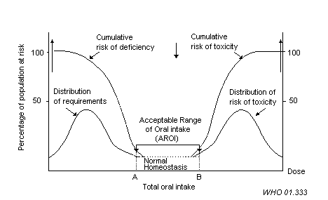
FIGURE 1. Theoretical Representation of the Acceptable Range of Oral Intake (IPCS, 2002). Reprinted with permission from the World Health Organization.

TABLE 1. Quality Considerations for Human and Animal Studies

Quality Considerations
Human Studies | Animal Studies
The study included multiple endpoints.  Copper balance studies provided adequate repletion following the period of copper depletion.  Controlled clinical study environment or design is optimal; however, other study designs may be adequate.  Accurate estimates of copper intake were available.  Data were subject to adequate statistical analyses.  Separate analyses have been conducted for infants, children and adults. | The animal species and strain was considered to be a suitable model for the purpose of human health risk assessment.  The exposure medium was relevant to human health risk assessment.  Standard considerations for animal study design and performance were applied.  In the case of dietary exposure studies, pair feeding designs are optimal; however, other study designs may also be appropriate.  The data was subject to appropriate statistical analyses.  Separate analyses were conducted based on the age of the animals in the study.

TABLE 2. Exclusion Criteria for Human and Animal Studies

Exclusion Criteria

There was inadequate information to characterize the dose and duration of exposure.

The information could not be entirely attributed to the effects of copper alone (confounders).

Copper was considered as the outcome and not the intervention.

Animals or humans have features suggestive of disturbed copper metabolism (transgenic animals, humans with genetic disease, or dietary copper deficiency).

The exposure route was not relevant for humans.

The animal model is not suitable for human health risk assessment (e.g., ruminant species, invertebrate species).

There was inadequate statistical reporting of the data.

TABLE 3. Severity Scoring Matrix
← ← ←Deficiency |  |  |  |  | Homeostasis | ← No Effect → |  | Homeostasis | Excess → → →
6 | 5 | 4 | 3 | 2 | 1 | 0 | 0 | 1 | 2 | 3 | 4 | 5 | 6
Death | Serious irreversible gross deficiency | Reversible  gross deficiency | Metabolic perturbation | Early phenomenon of deficient levels of copper | No evidence of Cu imbalance. |  |  | No evidence of Cu imbalance. | Early phenomenon of accumulated copper | Metabolic perturbation | Reversible gross excess | Serious irreversible gross Excess | Death
 |  | Gross threatening disturbances of metabolism; disturbances of peripheral products; depletion of liver Cu stores | Metabolic perturbation or change in metabolism of other metals (e.g. Fe); altered immune function; cardiac hypertrophy; membrane fluidity changes; anemia | Loss of Cu-dependent enzyme function especially in tissues with rapid turnover (GI, mucosa); changes in blood cell number or function; altered SOD activity | Use of endogenous Cu stores; decreased Cu excretion; increased GI Cu acquisition |  |  | Increased Cu excretion; decreased GI Cu absorption; increased Cu deposition in liver | Changes in Cu dependent enzyme function; changes in Cu absorption & transport; changes in cholesterol and triglyceride levels in blood and liver; large increases in liver Cu burden | Increased GI metallothion-nein levels, kidney droplets; increased systolic blood pressure; decreased weight gain | Gross dysfunction, disturbances in metabolism of other nutrients; gross changes in morphology

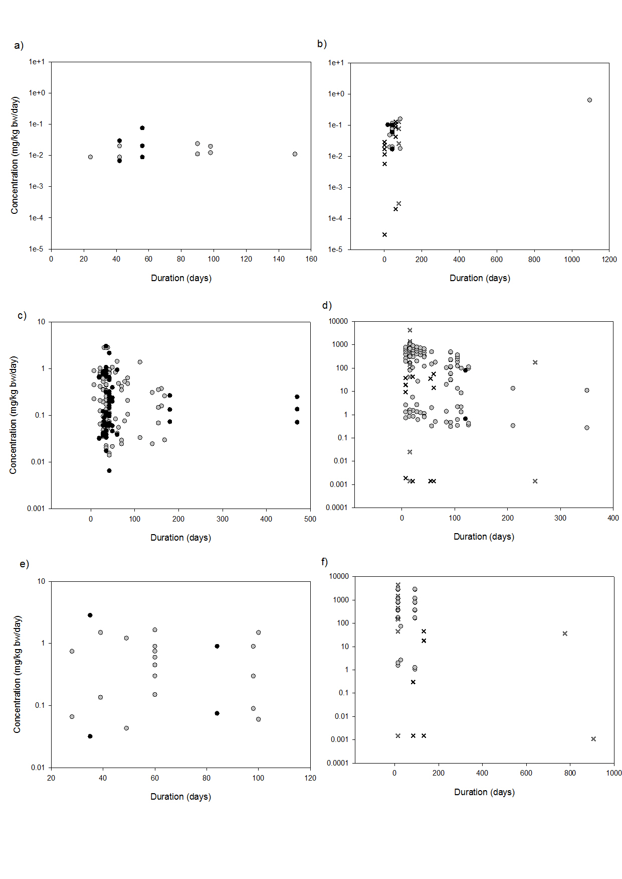
FIGURE 2a-f. Copper deficiency data before and after the database update for humans (a), rats (c) and mice (e), respectively. Copper excess data before and after the database update for humans (b), rats (d), and mice (f), respectively. Observations from dietary studies up until 2002 = , Observations from dietary studies post 2002 = . Drinking water studies up until 2002 = X, Drinking water studies post 2002 = X.

TABLE 4. Number of Observations* by Animal Species and Severity Score
 | Severity Levels
Factor | 0 | 1 | 2 | 3 | 4 | 5 | 6
Copper Excess

Humans | 12 (28) | 0 | 4 (5) | 0 | 6 (13) | 0 | 0
Rats | 7 (55) | 0 (8) | 0 (3) | 2 (17) | 4 (46) | 0 (3) | 0 (4)
Mice | 2 (21) | 0 | 0 | 2 (4) | 0 (14) | 0 | 0 (5)
Pigs  Rabbits | 8 (8)  1 (1) | 0  0 | 3 (3)  0 | 3 (3)  1 (1) | 0  0 | 0  0 | 0  0
Copper Deficiency

Humans | 2 (5) | 2 (3) | 0 (3) | 1 (2) | 0 | 0 | 0
Rats | 27 (74) | 6 (10) | 6 (22) | 21 (64) | 5 (6) | 0 | 0 (1)
Mice | 2 (11) | 6 (0) | 0 (1) | 2 (2) | 0 (4) | 0 | 0
Pigs | 0 (1) | 0 | 0 | 0 (1) | 0 | 0 | 0
* Bolded values represent the number of observations added from the literature review update and values in parenthesise represent the total number of observations including those identified prior to 2002.

TABLE 5. AIC for 24 Modeling Options for Copper Excess and Deficiency
 |  |  | AIC
Link Function | C | T | Deficiency | Excess
Logit  Logit  Logit  Logit | Linear  Linear  Log  Log | Linear  Log  Linear  Log | 514.3146  511. 2093  514.3866  511.1258 | 576.76  574.78  547.11  541.52
Probit  Probit  Probit  Probit | Linear  Linear  Log  Log | Linear  Log  Linear  Log | 518.7908  517.7919  518.8718  517.8761 | 579.49  579.79  574.04  543.70
C Log-log  C Log-log  C Log-log  C Log-log | Linear  Linear  Log  Log | Linear  Log  Linear  Log | 514.5548  505.7347  514.6525  505.8695 | NA*  NA*  NA*  NA*

TABLE 6. Stratification Options in the Cumulative Odds Model for the Copper Excess and Copper Deficiency Data
Stratification Option | Chi-square | df | P-value
Copper Excess:  Intercept Stratified by Animal Speciesª  Intercept Stratified by Exposure Medium^{b}  Concentration Stratified by Animal Species^{c}  Concentration Stratified by Age^{b} | 20.98  7.07  8.07  11.40 | 4  3  3  2 | <0.05  <0.05  <0.05  <0.05
Copper Deficiency:  Intercept Stratified by Animal Species^{c}  Intercept Stratified by Age^{b} | 83.62  11.93 | 3  2 | <0.0001  <0.01
Note. Cumulative odds model of the copper excess data uses the logit link function and stratifies the intercept by animal species and exposure medium and stratifies the duration parameter by age. Cumulative odds model of the copper deficiency data uses the probit link function and stratifies the intercept by animal species and the concentration parameter by age.
ªControlling for the exposure medium (drinking water or diet)
^{b}Controlling for animal species (humans, rats or mice)
^{c}Controling for age (mature or young)

TABLE 7. Parameter Estimates, Standard Errors, Z-test Statistics and P-values for Copper Excess Studies Using the Cumulative Odds Model*
Parameter | Estimate | Std. Error | Z-test | P-value
SEV1  SEV2  SEV3  SEV4  HU:F:INTERCEPT  HU:W:INTERCEPT  MU:F:INTERCEPT  MU:W:INTERCEPT  RT:F:INTERCEPT  RT:W:INTERCEPT  HU:2:LG10CONC  MU:1:LG10CONC  MU:2:LG10CONC  RT:1:LG10CONC  RT:2:LG10CONC  LG10TIME | 5.8797  5.4416  5.0383  4.0248  0.0000  1.9743  -19.1012  -15.6647  -13.8327  -12.9416  9.7482  5.8122  3.8369  3.2419  2.4122  2.5437 | 3.1609  3.2080  3.2206  3.2062  0.0000  1.2831  7.6620  5.9865  3.1243  3.2232  2.8460  3.7392  2.4670  0.4016  0.3361  0.6976 | 1.8601  1.6963  1.5644  1.2553  NA  1.5387  -2.4930  -2.6167  -4.4274  -4.0152  3.4252  1.5544  1.5537  8.0731  7.17777  3.6463 | 0.0629  0.0898  0.1177  0.2094  NA  0.1239  0.0127  0.0089  <0.0001  <0.0001  0.006  0.1201  0.1203  <0.0001  <0.0001  <0.001
* Cumulative odds model uses the logit link function. Concentration (mg/kg bw/days) and duration (days) have been log transformed to the base 10. Note. SEV, severity level; LG10, log transformed to the base 10; CONC, concentration coefficient; TIME, duration coefficient; HU, humans; RT, rats; MU, mice; F, dietary studies; W, drinking water studies; 1, young animal (≤30 days of age); 2, mature animal (>30 days of age for rodents and ≥18 years for humans).

TABLE 8. Parameter Estimates, Standard Errors, Z-test Statistics and P-values for the Cumulative Odds Model* of the Copper Deficiency Data
Parameter | Estimate | Std. Error | Z-test | P-value
SEV1  SEV2  SEV3  SEV4  HU:2:INTERCEPT  MU:1:INTERCEPT  MU:2:INTERCEPT  RT:1:INTERCEPT  RT:2:INTERCEPT  LG10CONC  LG10TIME | -9.7115  -10.5141  -11.7843  -15.8934  0.0000  9.2461  7.6482  6.7146  4.6963  -5.2314  0.2247 | 1.7215  1.7354  1.7663  1.9502  0.0000  1.7256  1.0245  0.7683  0.6322  0.5517  0.9321 | -5.6414  -6.0585  -6.6720  -8.1498  NA  5.3583  7.4655  8.7391  7.4285  -9.4817  0.2410 | <0.0001  <0.0001  <0.0001  <0.0001  NA  <0.0001  <0.0001  <0.0001  <0.0001  <0.0001  0.8095
* Cumulative odds model uses the logit link function. Concentration (mg/kg bw/day) and duration (days) log transformed (log10). Note. SEV, severity level; LG10, log transformed to the base 10; CONC, concentration coefficient; TIME, duration coefficient; HU, humans; MU, mice; RT, rats; 2, mature animals (>30 days of age) or adult humans (≥18 years of age); 1 = young animals (≤30 days of age).

a)
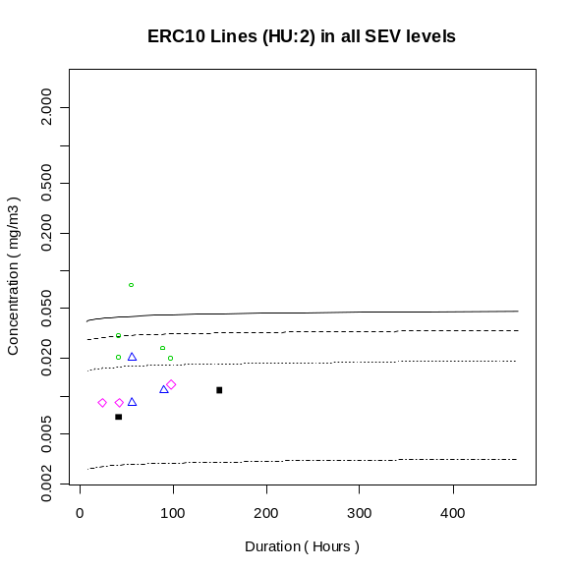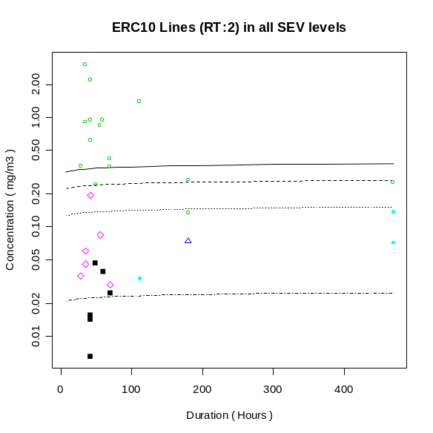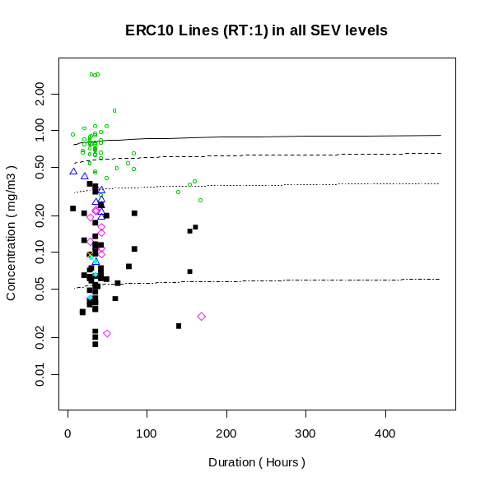
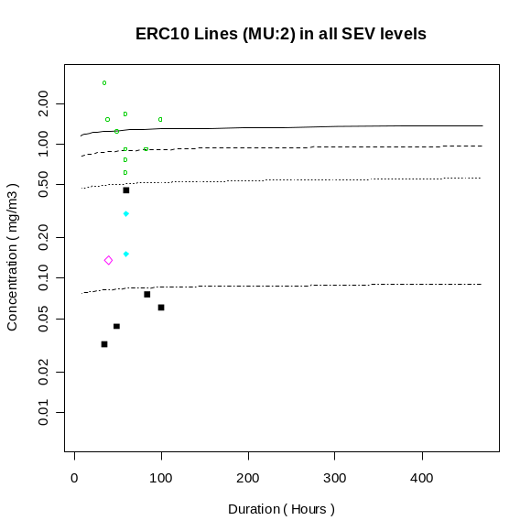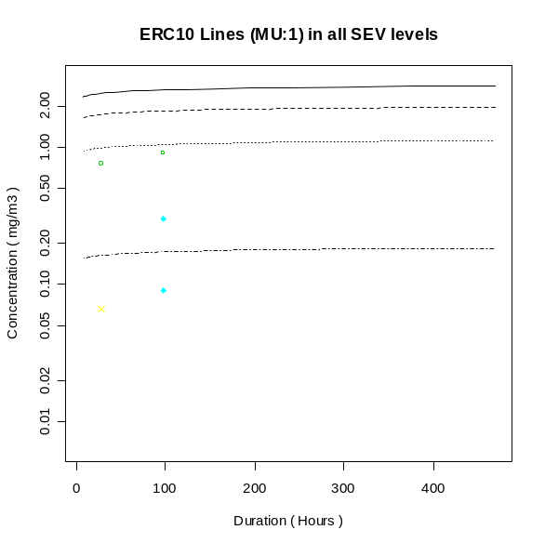
a)
b)
c)
Concentration (mg/kg bw/day)
Sev 1
Sev 1
Sev 2
Human Stratum – ERC10 Lines for all Severity Levels
Mature Rat Stratum – ERC10 Lines for all Severity Levels
Young Rat Stratum – ERC10 Lines for all Severity Levels
b)
c)
Sev 3
Sev 2
Sev 3
Sev 4
Sev 1
Sev 2
Sev 3
Sev 4
Sev 4

Duration (Days)
Duration (Days)
Duration (Days)
d)
e)
Concentration (mg/kg bw/day)
Sev 1
Sev 2
Sev 1
Sev 2
Sev 3
d)
Sev 3
Sev 4
Mature Mice Stratum – ERC10 Lines for all Severity Levels
Young Mice Stratum – ERC10 Lines for all Severity Levels
e)
Sev 4

Duration (Days)
Duration (Days)
FIGURE 3. ERC10 line for all severity levels for humans (a), mature rats (b), young rats (c), mature mice (d), and young mice (e). Cumulative odds model of the copper deficiency data with the logit link function transforms concentration (mg/kg bw/day) and duration (days) to the base 10. Intercept stratified by animal species and concentration by age. Data points are represented as: = severity level 0, = severity level 1, = severity level 2, = severity level 3, = severity level 4. Note that severity level 2 or greater is considered serious or adverse. RT = rats, MU = mice, HU = humans, 2 = mature, 1 = young.
a)

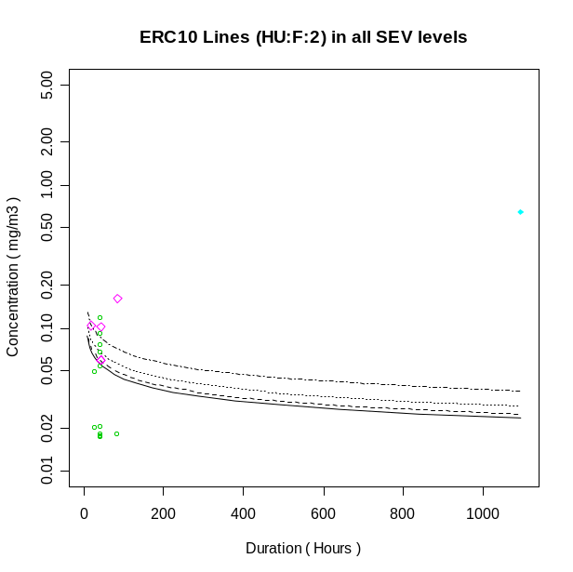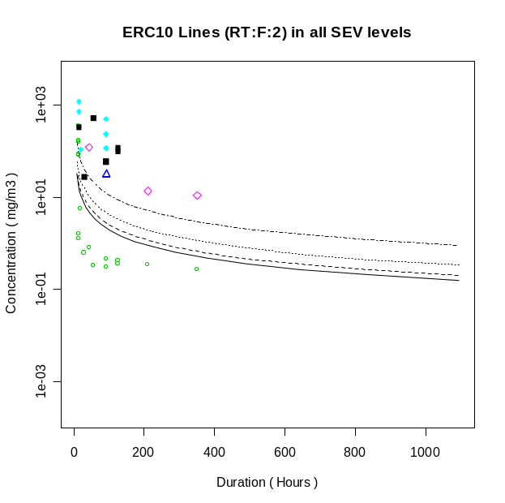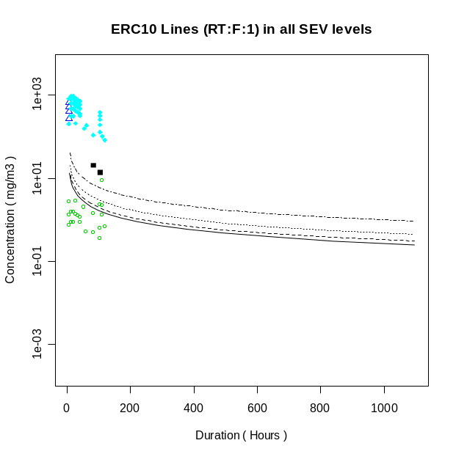
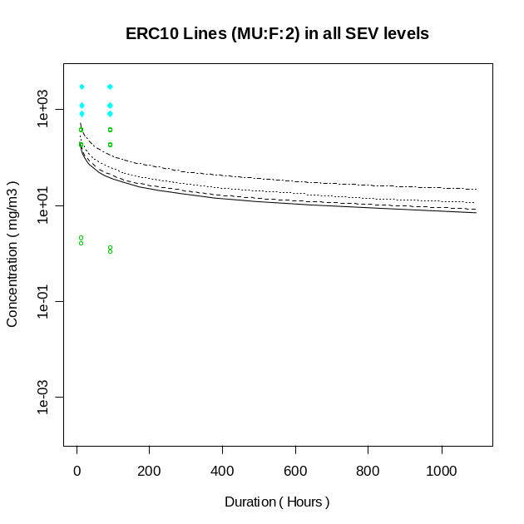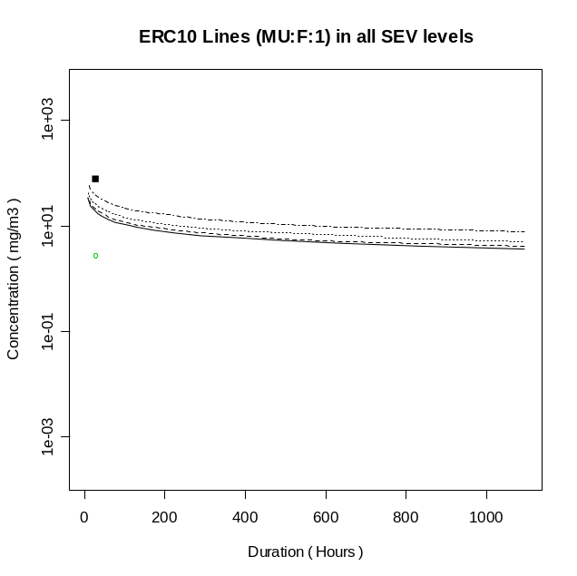
ERC10 Lines (HU:2) for all SEV levels
a)
b)
c)

Concentration (mg/kg bw/day)

Sev 4
Sev 3
Sev 3
Sev 4
Sev 2
Sev 1
Sev 2
Sev 1
Sev 4
Sev 3
Sev 2
Sev 1

Duration (Days)
Duration (Days)
Duration (Days)
d)
e)

Concentration (mg/kg bw/day)
Sev 4
Sev 3
Sev 3
Sev 4
Sev 2
Sev 1
Sev 2
Sev 1
v

Duration (Days)
Duration (Days)
FIGURE 4. ERC10 line for all severity levels for humans (a), mature rats (b), young rats (c), mature mice (d), and young mice (e). Cumulative odds model of the copper excess data with the logit link function transforms concentration (mg/kg bw/day) and duration (days) to the base 10. Intercept stratified by animal species and the exposure medium and concentration stratified by animal species and age. Data points are represented as: = severity level 0, = severity level 1, = severity level 2, = severity level 3, = severity level 4. Note that severity level 2 or greater is severe. RT = rats, MU = mice, HU = humans, 2 = mature, 1 = young.
a)

TABLE 9. ERC10 Estimates in mg/kg bw/day at Severity level 2 or Greater with 90% Confidence Intervals by Animal Species, Exposure Medium and Age for Copper Deficiency and Excess
 |  | Cu Deficiency |  |  | Cu Excess
Age | Exposure Medium | Humans | Rats | Mice | Humans | Rats | Mice
Mature | Feed | 0.03 (0.02, 0.05) | 0.25 (0.15, 0.42) | 0.91 (0.47, 1.74) | 0.05 (0.03, 0.08) | 2.51 (1.20, 5.25) | 41.19 (2.52, 674.43)
 | Water | -- | -- | -- | 0.03 (0.02, 0.05) | 1.07 (0.20, 5.62) | 5.25 (0.24, 115.83)
Young | Feed | -- | 0.61 (0.41, 0.89) | 1.84 (0.55, 6.11) | --- | 1.99 (1.13, 3.50) | 11.68 (1.89, 72.33)

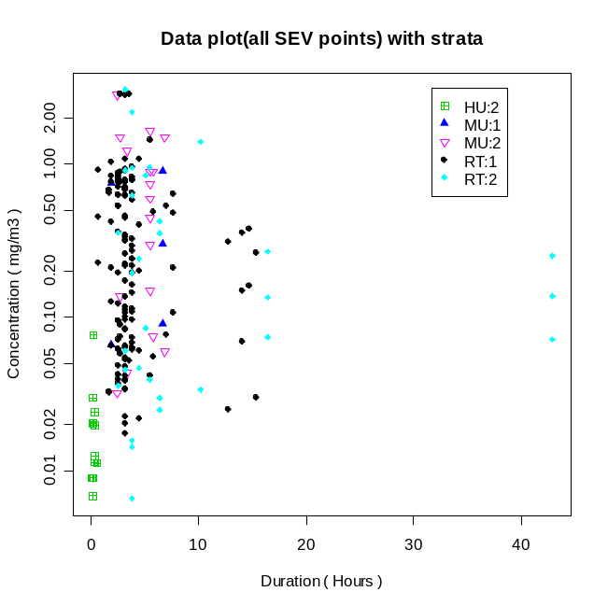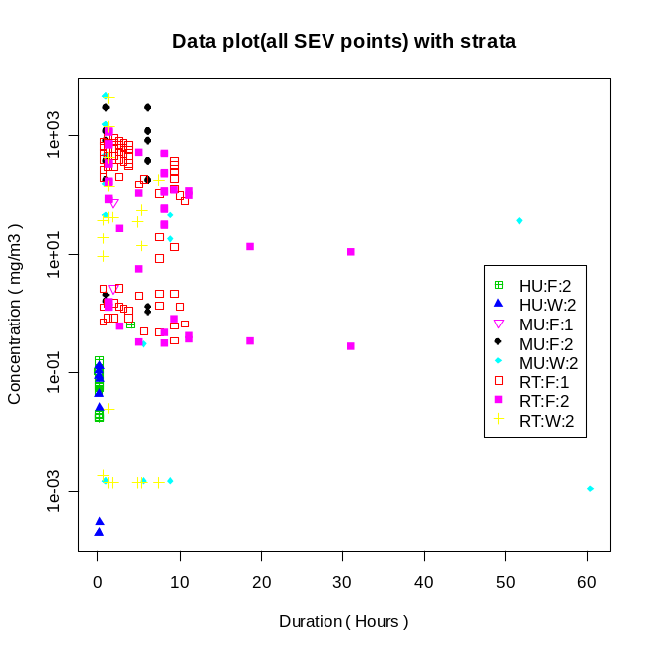
Copper Deficiency Data with Strata
Copper Excess Data with Strata
a)
b)
Concentration (mg/kg bw/day)
Concentration (mg/kg bw/day)

Duration (Percent Lifespan)
Duration (Percent Lifespan)

FIGURE 5a-b. Copper deficiency data (5a) and excess data (5b) defined by dose (mg/kg bw/day) and duration (percent lifespan). RT = rats, MU = mice, HU = humans, 2 = mature, 1 = young, F = dietary study, W= drinking water study.

TABLE 10. Comparison of the Combined Analysis with the Species-Specific Analysis: ERC10-T100 Estimates (mg/kg bw/day) with 90% Confidence Intervals at Severity level 2 or Greater for Copper Excess
 | ERC10-T100 (90% Confidence Interval)
Stratum | Combined Analysisª | Species-Specific Analysis
Humans^{b} | 0.05 (0.03, 0.08) | 0.04 (0.01, 0.21)
Mature Rats^{c} | 2.51 (1.20, 5.25) | 3.56 (1.53, 8.28)
Mature Mice^{d} | 41.19 (2.52, 674.43) | ---
ª Original model in the combined analysis contains all data on humans, rats and mice. For copper excess, the intercept is stratified by animal species and the exposure medium and the concentration parameter is stratified by animal species and age.
^{b} In the species-specific model with human data, the model’s intercept was stratified by the exposure medium.
^{c} In the species-specific model with rat data, the intercept was stratified by the exposure medium and the concentration parameter was stratified by age.
^{d} Mice only model could not be defined due to limited data.

TABLE 11. Comparison of the Combined Analysis with the Species-Specific Analysis: ERC10-T100 Estimates (mg/kg bw/day) with 90% Confidence Intervals at Severity level 2 or Greater for Copper Deficiency
 | ERC10-T100 (90% Confidence Interval)
Stratum | Combined Analysisª | Species-Specific Analysis
Humans^{b} | 0.03 (0.02, 0.05) | 0.02 (0.01, 0.02)
Mature Rats^{c} | 0.25 (0.15, 0.42) | 0.24 (0.13, 0.42)
Mature Mice^{d} | 0.91 (0.47, 1.74) | ---
ª Original model in the combined analysis contains all data on humans, rats and mice. For copper deficiency, the intercept is stratified by animal species and age.
^{b} Human only model for copper deficiency combines severity scores 1-2 and 3-6 and stratifies the intercept by means of exposure.
^{c} In the species-specific model with rat data, the intercept is stratified by age.
^{d} Mice only model could not be defined due to limited data

Table 12. Comparison of Original and Updated Copper Database: ERC10-T100 Estimates (mg/kg bw/day) with 90% Confidence at Severity Level 2 or Greater
 | ERC10-T100 (90% Confidence Interval)
Stratum | Deficiencyª | Excess^{b}
Pre-database Update | 0.032 (0.021, 0.049) | 0.076 (0.038, 0.152)
Database Update | 0.031 (0.022, 0.045) | 0.047 (0.028, 0.078)
ªCopper deficiency models stratify intercept by animal species and age.
^{b}Copper excess models stratify intercept by animal species and exposure medium and the concentration parameter by animal species and age.

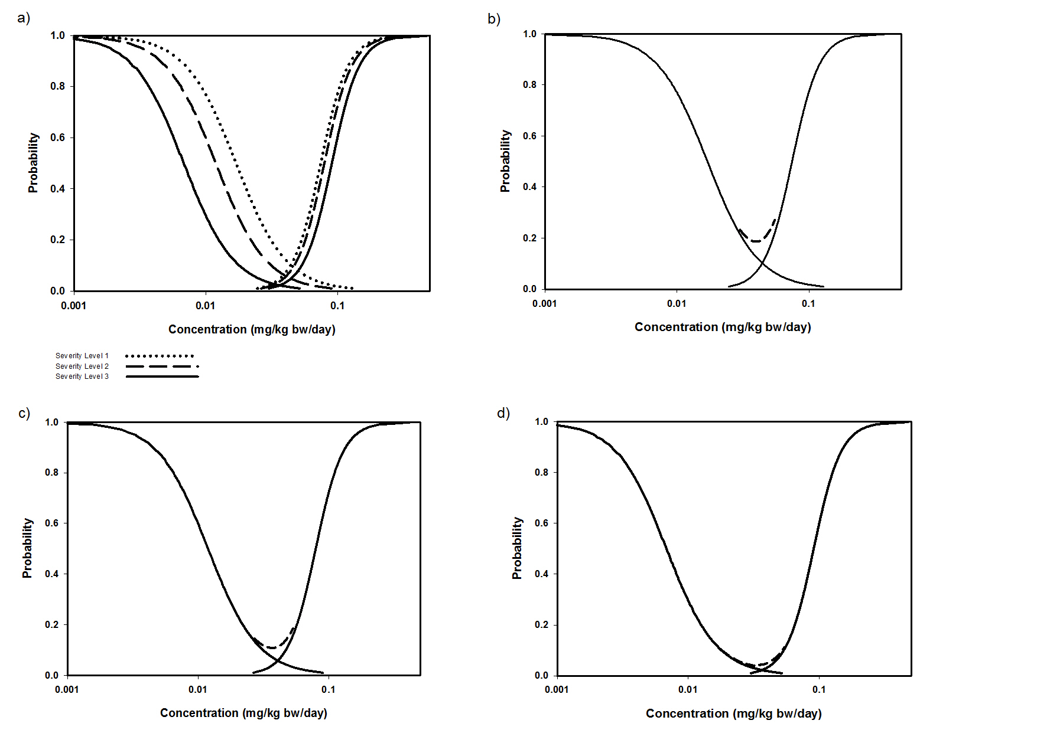

FIGURE 6a-d. Figure 6a presents probability curves for copper deficiency and copper excess for severity levels 1 to 3. Figures 6b-d present probability curves for copper deficiency and excess for severity levels 1 to 3, respectively. Each figure (6b-d) also presents the summative probability curves defined by Equation 1. This curve is represented by:

APPENDIX A: Summary Tables of Animal and Human Studies from the Copper Exposure Response Database

TABLE A1: References and Observations on Copper Excess
Ref. (ID#) | Test Type | Species | Strain | Copper Species | Route of Admin. | Life stage | Sex | Exp. | Grp. | Conc. | Days | Sev.
Baker 1999a (2) | Subacute Toxicity | Human | NA | CuSO₄ | Capsule | Adult | M | 1 | 1 | 0 mg/d | 42 | 0
 |  |  |  |  |  |  |  | 1 | 2 | 3 mg/d | 42 | 0
 |  |  |  |  |  |  |  | 1 | 3 | 6 mg/d | 42 | 0
 |  |  |  |  |  |  | F | 2 | 1 | 0 mg/d | 42 | 0
 |  |  |  |  |  |  |  | 2 | 2 | 3 mg/d | 42 | 0
 |  |  |  |  |  |  |  | 2 | 3 | 6 mg/d | 42 | 0
Pratt 1985 (6) | Subchronic Toxicity | Human | NA | C12 H22 CuO | Capsule | Adult | B | 1 | 1 | 0 mg/d | 84 | 0
 |  |  |  |  |  |  |  | 1 | 2 | 10 mg/d | 84 | 2
Murthy 1981 (10) | Subacute Toxicity | Rats | NS | CuSO₄ | Feed | Adult | M | 1 | 1 | 0 mg/d | 30 | 0
 |  |  |  |  |  |  |  | 1 | 2 | 5 mg/d | 30 | 3
Jones 1997 (14) | Subacute | Human | NA | CuG | Capsule | NS | M | 1 | 1 | 0 mg/d | 28 | 0
 |  |  |  |  |  |  |  | 1 | 2 | 2 mg/d | 28 | 0
Haywood 1985 (20) | Subacute Toxicity | Rats | Wistar | CuSO₄ | Feed | Weanling | M | 1 | 1 | 10 mg/kg | 7 | 0
 |  |  |  |  |  |  |  | 1 | 2 | 3000 mg/kg | 7 | 1
 |  |  |  |  |  |  |  | 1 | 3 | 4000 mg/kg | 7 | 1
 |  |  |  |  |  |  |  | 1 | 4 | 5000 mg/kg | 7 | 1
 |  |  |  |  |  |  |  | 1 | 5 | 6000 mg/kg | 7 | 4
 |  |  |  |  |  |  |  | 2 | 1 | 10 mg/kg | 14 | 0
 |  |  |  |  |  |  |  | 2 | 2 | 3000 mg/kg | 14 | 4
 |  |  |  |  |  |  |  | 2 | 3 | 4000 mg/kg | 14 | 4
 |  |  |  |  |  |  |  | 2 | 4 | 5000 mg/kg | 14 | 4
 |  |  |  |  |  |  |  | 2 | 5 | 6000 mg/kg | 14 | 4
 |  |  |  |  |  |  |  | 3 | 1 | 10 mg/kg | 21 | 0
 |  |  |  |  |  |  |  | 3 | 2 | 3000 mg/kg | 21 | 4
 |  |  |  |  |  |  |  | 3 | 3 | 4000 mg/kg | 21 | 4
 |  |  |  |  |  |  |  | 3 | 4 | 5000 mg/kg | 21 | 4
 |  |  |  |  |  |  |  | 3 | 5 | 6000 mg/kg | 21 | 4
 |  |  |  |  |  |  |  | 4 | 1 | 10 mg/kg | 28 | 0
 |  |  |  |  |  |  |  | 4 | 2 | 3000 mg/kg | 28 | 4
 |  |  |  |  |  |  |  | 4 | 3 | 4000 mg/kg | 28 | 4
 |  |  |  |  |  |  |  | 4 | 4 | 5000 mg/kg | 28 | 4
 |  |  |  |  |  |  |  | 4 | 5 | 6000 mg/kg | 28 | 4
 | Subchronic Toxicity |  |  |  |  |  |  | 5 | 1 | 10 mg/kg | 35 | 0
 |  |  |  |  |  |  |  | 5 | 2 | 3000 mg/kg | 35 | 4
 |  |  |  |  |  |  |  | 5 | 3 | 4000 mg/kg | 35 | 4
 |  |  |  |  |  |  |  | 5 | 4 | 5000 mg/kg | 35 | 4
 |  |  |  |  |  |  |  | 5 | 5 | 6000 mg/kg | 35 | 5
 |  |  |  |  |  |  |  | 6 | 1 | 10 mg/kg | 42 | 0
 |  |  |  |  |  |  |  | 6 | 2 | 3000 mg/kg | 42 | 4
 |  |  |  |  |  |  |  | 6 | 3 | 4000 mg/kg | 42 | 4
 |  |  |  |  |  |  |  | 6 | 4 | 5000 mg/kg | 42 | 4
 |  |  |  |  |  |  |  | 6 | 5 | 6000 mg/kg | 42 | 5
 | Chronic Toxicity |  |  |  |  |  |  | 7 | 1 | 10 mg/kg | 105 | 0
 |  |  |  |  |  |  |  | 7 | 2 | 3000 mg/kg | 105 | 4
 |  |  |  |  |  |  |  | 7 | 3 | 4000 mg/kg | 105 | 4
 |  |  |  |  |  |  |  | 7 | 4 | 5000 mg/kg | 105 | 4
 |  |  |  |  |  |  |  | 7 | 5 | 6000 mg/kg | 105 | 5
Haywood 1980 (22) | Subacute Toxicity | Rats | NS | CuSO₄ | Feed | Weanling | M | 1 | 1 | 0 ppm | 7 | 0
 |  |  |  |  |  |  |  | 1 | 2 | 2000 ppm | 7 | 1
 | Subacute Toxicity |  |  |  |  |  |  | 2 | 1 | 0 ppm | 14 | 0
 |  |  |  |  |  |  |  | 2 | 2 | 2000 ppm | 14 | 4
 | Subacute Toxicity |  |  |  |  |  |  | 3 | 1 | 0 ppm | 21 | 0
 |  |  |  |  |  |  |  | 3 | 2 | 2000 ppm | 21 | 4
 | Subchronic Toxicity |  |  |  |  |  |  | 4 | 1 | 0 ppm | 42 | 0
 |  |  |  |  |  |  |  | 4 | 2 | 2000 ppm | 42 | 4
 | Subchronic |  |  |  |  |  |  | 5 | 1 | 0 ppm | 63 | 0
 |  |  |  |  |  |  |  | 5 | 2 | 2000 ppm | 63 | 4
 | Chronic |  |  |  |  |  |  | 6 | 1 | 0 ppm | 105 | 0
 |  |  |  |  |  |  |  | 6 | 2 | 2000 ppm | 105 | 4
Fuentealba 2000 (25) | Chronic | Rats | Fischer 344 | CuSO₄ | Feed | Adult | M | 1 | 1 | 0 ppm | 126 | 0
 |  |  |  |  |  |  |  | 1 | 2 | 1500 ppm | 126 | 3
 |  |  |  |  |  |  | F | 2 | 1 | 0 ppm | 126 | 0
 |  |  |  |  |  |  |  | 2 | 2 | 1500 ppm | 126 | 3
Hebert 1993 (26) | Subacute Toxicity | Rats | Fischer 344 | CuSO₄ | Water | Adult | M | 1 | 1 | 0 ppm | 15 | 0
 |  |  |  |  |  |  |  | 1 | 2 | 300 ppm | 15 | 0
 |  |  |  |  |  |  |  | 1 | 3 | 1000 ppm | 15 | 0
 |  |  |  |  |  |  |  | 1 | 4 | 3000 ppm | 15 | 3
 |  |  |  |  |  |  |  | 1 | 5 | 10000 ppm | 15 | 6
 |  |  |  |  |  |  |  | 1 | 6 | 30000 ppm | 15 | 6
 | Subacute Toxicity | Mice | B6C3F1 | CuSO₄ | Water | Adult | M | 2 | 1 | 0 ppm | 15 | 0
 |  |  |  |  |  |  |  | 2 | 2 | 300 ppm | 15 | 0
 |  |  |  |  |  |  |  | 2 | 3 | 1000 ppm | 15 | 0
 |  |  |  |  |  |  |  | 2 | 4 | 3000 ppm | 15 | 4
 |  |  |  |  |  |  |  | 2 | 5 | 10000 ppm | 15 | 6
 |  |  |  |  |  |  |  | 2 | 6 | 30000 ppm | 15 | 6
 | Subacute Toxicity | Rats | Fischer 344 | CuSO₄ | Water | Adult | F | 3 | 1 | 0 ppm | 15 | 0
 |  |  |  |  |  |  |  | 3 | 2 | 300 ppm | 15 | 0
 |  |  |  |  |  |  |  | 3 | 3 | 1000 ppm | 15 | 0
 |  |  |  |  |  |  |  | 3 | 4 | 3000 ppm | 15 | 3
 |  |  |  |  |  |  |  | 3 | 5 | 10000 ppm | 15 | 6
 |  |  |  |  |  |  |  | 3 | 6 | 30000 ppm | 15 | 6
 | Subacute Toxicity | Mice | B6C3F1 | CuSO₄ | Water | Adult | F | 4 | 1 | 0 ppm | 15 | 0
 |  |  |  |  |  |  |  | 4 | 2 | 300 ppm | 15 | 0
 |  |  |  |  |  |  |  | 4 | 3 | 1000 ppm | 15 | 3
 |  |  |  |  |  |  |  | 4 | 4 | 3000 ppm | 15 | 4
 |  |  |  |  |  |  |  | 4 | 5 | 10000 ppm | 15 | 6
 |  |  |  |  |  |  |  | 4 | 6 | 30000 ppm | 15 | 6
 | Subacute Toxicity | Rats | Fischer 344 | CuSO₄ | Feed | Adult | M | 5 | 1 | 0 ppm | 15 | 0
 |  |  |  |  |  |  |  | 5 | 2 | 1000 ppm | 15 | 0
 |  |  |  |  |  |  |  | 5 | 3 | 2000 ppm | 15 | 0
 |  |  |  |  |  |  |  | 5 | 4 | 4000 ppm | 15 | 0
 |  |  |  |  |  |  |  | 5 | 5 | 8000 ppm | 15 | 4
 |  |  |  |  |  |  |  | 5 | 6 | 16000 ppm | 15 | 4
 | Subacute Toxicity | Rats | Fischer 344 | CuSO₄ | Feed | Adult | F | 6 | 1 | 0 ppm | 15 | 0
 |  |  |  |  |  |  |  | 6 | 2 | 1000 ppm | 15 | 0
 |  |  |  |  |  |  |  | 6 | 3 | 2000 ppm | 15 | 0
 |  |  |  |  |  |  |  | 6 | 4 | 4000 ppm | 15 | 3
 |  |  |  |  |  |  |  | 6 | 5 | 8000 ppm | 15 | 4
 |  |  |  |  |  |  |  | 6 | 6 | 16000 ppm | 15 | 4
 | Subacute Toxicity | Mice | B6C3F1 | CuSO₄ | Feed | Adult | M | 7 | 1 | 0 ppm | 15 | 0
 |  |  |  |  |  |  |  | 7 | 2 | 1000 ppm | 15 | 0
 |  |  |  |  |  |  |  | 7 | 3 | 2000 ppm | 15 | 0
 |  |  |  |  |  |  |  | 7 | 4 | 4000 ppm | 15 | 4
 |  |  |  |  |  |  |  | 7 | 5 | 8000 ppm | 15 | 4
 |  |  |  |  |  |  |  | 7 | 6 | 16000 ppm | 15 | 4
 | Subacute Toxicity | Mice | B6C3F1 | CuSO₄ | Feed | Adult | F | 8 | 1 | 0 ppm | 15 | 0
 |  |  |  |  |  |  |  | 8 | 2 | 1000 ppm | 15 | 0
 |  |  |  |  |  |  |  | 8 | 3 | 2000 ppm | 15 | 0
 |  |  |  |  |  |  |  | 8 | 4 | 4000 ppm | 15 | 4
 |  |  |  |  |  |  |  | 8 | 5 | 8000 ppm | 15 | 4
 |  |  |  |  |  |  |  | 8 | 6 | 16000 ppm | 15 | 4
 | Subchronic Toxicity | Rats | Fischer 344 | CuSO₄ | Feed | Adult | M | 9 | 1 | 0 ppm | 92 | 0
 |  |  |  |  |  |  |  | 9 | 2 | 500 ppm | 92 | 1
 |  |  |  |  |  |  |  | 9 | 3 | 1000 ppm | 92 | 3
 |  |  |  |  |  |  |  | 9 | 4 | 2000 ppm | 92 | 4
 |  |  |  |  |  |  |  | 9 | 5 | 4000 ppm | 92 | 4
 |  |  |  |  |  |  |  | 9 | 6 | 8000 ppm | 92 | 4
 | Subchronic Toxicity | Rats | Fischer 344 | CuSO₄ | Feed | Adult | F | 10 | 1 | 0 ppm | 92 | 0
 |  |  |  |  |  |  |  | 10 | 2 | 500 ppm | 92 | 1
 |  |  |  |  |  |  |  | 10 | 3 | 1000 ppm | 92 | 3
 |  |  |  |  |  |  |  | 10 | 4 | 2000 ppm | 92 | 4
 |  |  |  |  |  |  |  | 10 | 5 | 4000 ppm | 92 | 4
 |  |  |  |  |  |  |  | 10 | 6 | 8000 ppm | 92 | 4
 | Chronic Toxicity | Mice | B6C3F1 | CuSO₄ | Feed | Adult | M | 11 | 1 | 0 ppm | 92 | 0
 |  |  |  |  |  |  |  | 11 | 2 | 1000 ppm | 92 | 0
 |  |  |  |  |  |  |  | 11 | 3 | 2000 ppm | 92 | 0
 |  |  |  |  |  |  |  | 11 | 4 | 4000 ppm | 92 | 4
 |  |  |  |  |  |  |  | 11 | 5 | 8000 ppm | 92 | 4
 |  |  |  |  |  |  |  | 11 | 6 | 16000 ppm | 92 | 4
 | Chronic Toxicity | Mice | B6C3F1 | CuSO₄ | Feed | Adult | F | 12 | 1 | 0 ppm | 92 | 0
 |  |  |  |  |  |  |  | 12 | 2 | 1000 ppm | 92 | 0
 |  |  |  |  |  |  |  | 12 | 3 | 2000 ppm | 92 | 0
 |  |  |  |  |  |  |  | 12 | 4 | 4000 ppm | 92 | 4
 |  |  |  |  |  |  |  | 12 | 5 | 8000 ppm | 92 | 4
 |  |  |  |  |  |  |  | 12 | 6 | 16000 ppm | 92 | 4
Araya 2001 (35) | Acute Toxicity | Human | NA | CuSO₄ | Water | Adult | B | 1 | 1 | 0 mg/L | 1 | 0
 |  |  |  |  |  |  |  | 1 | 2 | 2 mg/L | 1 | 0
 |  |  |  |  |  |  |  | 1 | 3 | 4 mg/L | 1 | 0
 |  |  |  |  |  |  |  | 1 | 4 | 6 mg/L | 1 | 4
 |  |  |  |  |  |  |  | 1 | 5 | 8 mg/L | 1 | 4
Baker 1999b (37) | Subacute Toxicity | Humans | NA | CuSO₄ | Diet | Adult | M | 1 | 1 | 1.6 mg/day | 42 | 0
 |  |  |  |  |  |  |  |  |  | 6.0 mg/day | 42 | 0
Cristofori 1992 (42) | Chronic Toxicity | Rats | SD | NS | Diet | Adult | F | 1 | 1 | 5 ppm | 210 | 0
 |  |  |  |  |  |  |  | 1 | 2 | 200 ppm | 210 | 2
 | Chronic Toxicity | Rats | SD | NS | Diet | Adult | F | 2 | 1 | 5 ppm | 350 | 0
 |  |  |  |  |  |  |  | 2 | 2 | 200 ppm | 350 | 2
Cromwell 1989 (43) | Subacute Toxicity | Pig | HY | CuSO₄ | Diet | Weanling | B | 1 | 1 | 0 ppm | 28 | 0
 |  |  |  |  |  |  |  | 1 | 2 | 125 ppm | 28 | 3
 |  |  |  |  |  |  |  | 1 | 3 | 250 ppm | 28 | 3
 |  |  |  | CuO |  |  |  | 2 | 1 | 0 ppm | 28 | 0
 |  |  |  |  |  |  |  | 2 | 2 | 125 ppm | 28 | 0
 |  |  |  |  |  |  |  | 2 | 3 | 250 ppm | 28 | 0
Cunnane 1985 (44) | Subchronic Toxicity | Rats | SD | NS | Diet | Weaning | M | 1 | 1 | 6 mg/kg/d | 84 | 0
 |  |  |  |  |  |  |  | 1 | 2 | 250 mg/kg/d | 84 | 3
Fuentealba 1989 (48) | Subacute Toxicity | Rats | Wistar | NS | Diet | Weaning | M | 1 | 1 | 20 ppm | 7 | 0
 |  |  |  |  |  |  |  | 1 | 2 | 1500 ppm | 7 | 4
 |  |  |  |  |  |  |  | 2 | 1 | 20 ppm | 28 | 0
 |  |  |  |  |  |  |  | 2 | 2 | 1500 ppm | 28 | 4
 | Subchronic Toxicity |  |  |  |  |  |  | 3 | 1 | 20 ppm | 56 | 0
 |  |  |  |  |  |  |  | 3 | 2 | 1500 ppm | 56 | 4
 |  |  |  |  |  |  |  | 4 | 1 | 20 ppm | 84 | 0
 |  |  |  |  |  |  |  | 4 | 2 | 1500 ppm | 84 | 4
 | Chronic Toxicity |  |  |  |  |  |  | 5 | 1 | 20 ppm | 112 | 0
 |  |  |  |  |  |  |  | 5 | 2 | 1500 ppm | 112 | 4
Giovanetti 1998 (50) | Subacute Toxicity | Mice | B6C3F1 | CuSO₄ | Diet | Weaning | M | 1 | 1 | 4.98 ppm | 28 | 0
 |  |  |  |  |  |  |  | 1 | 2 | 200 ppm | 28 | 3
Gotteland 2001 (54) | Acute Toxicity | Humans | NS | CuSO₄ | Water | Adults | B | 1 | 1 | 10 mg/L | 1 | 4
Greene 1987 (55) | Chronic Toxicity | Rats | SD | NS | Diet | Weaning | M | 1 | 1 | 25 ppm | 112 | 0
 |  |  |  |  |  |  |  |  |  | 100 ppm | 112 | 0
Gross 1989 (56) | Chronic Toxicity | Rats | SD | CuAc | Water | Adult | M | 1 | 1 | 0 % | 252 | 0
 |  |  |  |  |  |  |  | 1 | 2 | 0.0125 % | 252 | 3
Jantsch 1985(63) | Acute Toxicity | Human | NA | CuSO₄ | Diet | Adult | M | 1 | 1 | 250 g/day | 1 | 4
Liu 1986 (75) | Chronic Toxicity | Rats | Wistar | CuCO₃ | Diet | Weaning | M | 1 | 1 | 18 mg/kg/d | 105 | 0
 |  |  |  |  |  |  |  | 1 | 2 | 100 mg/kg/d | 105 | 3
Mullins 1998 (80) | Subchronic Toxicity | Rats | Wistar | CuSO₄ | Diet | Adults | M | 1 | 1 | 10 mg/kg | 42 | 0
 |  |  |  |  |  |  |  | 1 | 2 | 1500 mg/kg | 42 | 2
O’Donohue 1999 (82) | Chronic Toxicity | Humans | NS | NS | Capsule | Adults | M | 1 | 1 | 45 mg/day | 1095 | 4
Zhang 2000 (98) | Subchronic Toxicity | Rats | Wistar | CuSO₄ | Capsule | Adult | B | 1 | 1 | 0 mg/kg/d | 40 | 0
 |  |  |  |  |  |  |  | 1 | 2 | 500 mg/kg/d | 40 | 3
Rana 1980 (99) | Subacute | Rats | Rattus | CuSO₄ | Diet | Adult | M | 1 | 1 | 0 mg/kg/day | 20 | 0
 |  |  |  |  |  |  |  | 1 | 2 | 100 mg/kg/day | 20 | 4
Massie 1984 (103) | Chronic Toxicity | Mice | C57B1/6J | C₁₂ H₂₂ CuO | Water | Adult | M | 1 | 1 | 0 ppm | NAª | 0
 |  |  |  |  |  |  |  | 1 | 2 | 317 ppm | NAª | 6
Pizarro 1999a (104) | Subchronic Toxicity | Human | NA | CuSO₄ | Water | Adult | F | 1 | 1 | 0 mg/L | 77 | 0
 |  |  |  |  |  |  |  | 1 | 2 | 1 mg/L | 77 | 0
 |  |  |  |  |  |  |  | 1 | 3 | 3 mg/L | 77 | 4
 |  |  |  |  |  |  |  | 1 | 4 | 5 mg/L | 77 | 4
Araya 2003a (109) | Acute Toxicity | Humans | NA | CuSO₄ | Water | Adult | B | 1 | 1 | 0 mg/l | 1 | 0
 |  |  |  |  |  |  |  | 1 | 2 | 10 mg/l | 1 | 4
Araya 2003b (110) | Acute Toxicity | Humans | NA | CuSO₄ | Water | Adult | F | 1 | 1 | 0 mg/l | 1 | 0
 |  |  |  |  |  |  |  | 1 | 2 | 2 mg/l | 1 | 0
 |  |  |  |  |  |  |  | 1 | 3 | 4 mg/l | 1 | 0
 |  |  |  |  |  |  |  | 1 | 4 | 6 mg/l | 1 | 4
 |  |  |  |  |  |  |  | 1 | 5 | 8 mg/l | 1 | 4
Araya 2003c (111) | Subchronic Toxicity | Humans | NA | CuSO₄ | Water | Adult | B | 1 | 1 | 0.01 mg/l | 60 | 0
 |  |  |  |  |  |  |  | 1 | 2 | 2 mg/l | 60 | 0
 |  |  |  |  |  |  |  | 1 | 3 | 4 mg/l | 60 | 0
 |  |  |  |  |  |  |  | 1 | 4 | 6 mg/l | 60 | 4
Araya 2004 (112) | Subchronic Toxicity | Humans | NA | CuSO₄ | Water | Adult | B | 1 | 1 | 0 mg/l | 60 | 0
 |  |  |  |  |  |  |  | 1 | 2 | 2 mg/l | 60 | 0
 |  |  |  |  |  |  |  | 1 | 3 | 4 mg/l | 60 | 4
 |  |  |  |  |  |  |  | 1 | 4 | 5 mg/l | 60 | 4
Armstrong 2004 (114) | Subchronic | Pigs | NS | CuSO₄ | Feed | Weanling | B | 1 | 1 | 10 ppm | 40 | 0
 |  |  |  |  |  |  |  | 1 | 2 | 135 ppm | 40 | 3
 |  |  |  |  |  |  |  | 1 | 3 | 260 ppm | 40 | 3
 |  |  |  | C₆H₄Cu₂O₇. |  |  |  | 2 | 1 | 15 ppm | 40 | 0
 |  |  |  |  |  |  |  | 2 | 2 | 46 ppm | 40 | 0
 |  |  |  |  |  |  |  | 2 | 3 | 77 ppm | 40 | 0
 |  |  |  |  |  |  |  | 2 | 4 | 140 ppm | 40 | 3
Cisternas 2005 (117) | Chronic | Rats | SD | CuSO₄ | Feed | Weanling | B | 1 | 1 | 10 ppm | 120 | 0
 |  |  |  |  |  |  |  | 1 | 2 | 1200 ppm | 120 | 4
Feng 2007 (126) | Subacute | Pigs | NS | CuSO₄ | Feed | NS | B | 1 | 1 | 12.4 mg/kg | 30 | 0
 |  |  |  |  |  |  |  | 1 | 2 | 250 mg/kg | 30 | 2
 |  |  |  |  |  |  |  | 2 | 1 | 12.4 mg/kg | 30 | 0
 |  |  |  | CuProt |  |  |  | 2 | 2 | 50 mg/kg | 30 | 0
 |  |  |  |  |  |  |  | 2 | 3 | 100 mg/kg | 30 | 2
Kvietkauskaite 2004 (136) | Subchronic | Mice | BALB/c | CuSO₄ | Water | Adults | M | 1 | 1 | 0 mg/kg bw/d | 133 | 0
 |  |  |  |  |  |  |  | 1 | 2 | 22 mg/kg bw/d | 133 | 3
 |  |  |  |  |  |  |  | 1 | 3 | 42 mg/kg bw/d | 133 | 3
O’Connor 2003 (138) | Subacute | Humans | NA | CuSO₄ | Capsule | Adult | B | 1 | 1 | 1.23 mg/d | 42 | 0
 |  |  |  |  |  |  |  | 1 | 2 | 4.23 mg/d | 42 | 1
 |  |  |  | CuG |  |  |  | 2 | 1 | 1.23 mg/d | 42 | 0
 |  |  |  |  |  |  |  | 2 | 2 | 4.23 mg/d | 42 | 1
 |  |  |  |  |  |  |  | 3 | 1 | 1.23 mg/d | 42 | 0
 |  |  |  |  |  |  |  | 3 | 2 | 7.23 mg/d | 42 | 1
Ozcelik 2002 (140) | Subchronic | Rats | Wistar | CuSO₄ | Water | Adult | B | 1 | 1 | 0 µg/mL | 54 | 0
 |  |  |  |  |  |  |  | 1 | 2 | 250 µg/mL | 54 | 3
Turnlund 2004 (146) | Subacute | Humans | NA | NS | Capsule | Adult | M | 1 | 1 | 7.8 mg/d | 18 | 2
Alissa 2004 (152) | Subchronic | Rabbits | NA | NS | Feed | Adult | M | 1 | 1 | 3.7 mg/d | 84 | 0
 |  |  |  |  |  |  |  | 1 | 2 | 350 mg/d | 84 | 3
Becaria 2006 (158) | Subchronic | Mice | B6C3F1 | CuSO₄ | Water | Adult | M | 1 | 1 | 0 ppm | 84 | 0
 |  |  |  |  |  |  |  | 1 | 2 | 2 ppm | 84 | 3
Davis 2002 (172) | Subacute | Pigs | NS | NS | Feed | Weanling | B | 1 | 1 | 20 ppm | 10 | 0
 |  |  |  |  |  |  |  | 1 | 2 | 195 ppm | 10 | 3
Goldschmith 2005 (178) | Subacute | Rats | NS | CuSO₄ | Water | Adult | B | 1 | 1 | 0.12 mg/d | 20 | 0
 |  |  |  |  |  |  |  | 1 | 2 | 12.12 mg/d | 20 | 4
Gurel 2007 (180) | Subchronic | Rats | SD | NS | Water | Adult | F | 1 | 1 | 0 mg/l | 60 | 0
 |  |  |  |  |  |  |  | 1 | 2 | 100 mg/l | 60 | 4
 |  |  |  |  |  |  |  | 1 | 3 | 400 mg/l | 60 | 4
Lai 2005 (187) | Subacute | Rats | Wistar | CuSO₄ | Water | Weanling | M | 1 | 1 | 0 µg/mL | 7 | 0
 |  |  |  |  |  |  |  | 1 | 2 | 50 µg/mL | 7 | 0
 |  |  |  |  |  |  |  | 1 | 3 | 100 µg/mL | 7 | 0
 |  |  |  |  |  |  |  | 1 | 4 | 200 µg/mL | 7 | 3
ªExposure duration = lifespan of each subject 500-975.
Note. Ref. (ID#), reference and identification number; NA, not applicable; NS, not specified; M, male; F, female; B, both male and female; Exp., experiment number within the publication; Grp., group number within the experiment; Conc., concentration reported in the study; Sev., severity score assigned; HU, humans; RT, rats, MU, mice; PG, pigs; SD, Sprague-Dawley; HY, Hamshire-yorkshire; CuG, copper glycine chelates; CuAc, copper acetate; CuProt, copper proteinate

TABLE A2: References and Observations on Copper Deficiency
Ref (ID#) | Exposure Duration Categories | Species | Strain | Copper Species | Route of Admin. | Life stage | Sex | Exp. | Grp. | Conc. | Days | Sev
Arce 1992 (1) | Subchronic | Mice | SW | CuSO₄ | Feed | Adult | F | 1 | 1 | 1 ppm | 39 | 2
 |  |  |  |  |  |  |  | 1 | 2 | 10 ppm | 39 | 0
DiSilvestro 1992 (4) | Subchronic | Rats | SD | CuSO₄ | Feed | Postweanling | M | 1 | 1 | 8 ppm | 42 | 0
 |  |  |  |  |  |  |  | 1 | 2 | 2.5 ppm | 42 | 2
 |  |  |  |  |  |  |  | 1 | 3 | 0.2 ppm | 42 | 3
Klevay 1985 (8) | Chronic | Mice | SW | CuSO₄ | Water | Adult | F | 1 | 1 | 0 µg/ml | NAª | 3
 |  |  |  |  |  |  |  | 1 | 2 | 10 µg/ml | NAª | 0
Schuschke 1999 (16) | Subacute | Rats | SD | CuSO₄ | Feed | Weaning | M | 1 | 1 | 0 ppm | 28 | 3
 |  |  |  |  |  |  |  | 1 | 2 | 1.5 ppm | 28 | 3
 |  |  |  |  |  |  |  | 1 | 3 | 3 ppm | 28 | 3
 |  |  |  |  |  |  |  | 1 | 4 | 6 ppm | 28 | 0
Schuschke 1995 (17) | Subacute | Rats | SD | NS | Feed | Weaning | M | 1 | 1 | 6 ppm | 7 | 0
 |  |  |  |  |  |  |  | 1 | 2 | 3 ppm | 7 | 1
 |  |  |  |  |  |  |  | 1 | 3 | 1.5 ppm | 7 | 3
 |  |  |  |  |  |  |  | 2 | 1 | 1.5 ppm | 21 | 3
 |  |  |  |  |  |  |  | 2 | 2 | 3 ppm | 21 | 1
 |  |  |  |  |  |  |  | 2 | 3 | 6 ppm | 21 | 0
 |  |  |  |  |  |  |  | 3 | 1 | 1.5 ppm | 35 | 3
 |  |  |  |  |  |  |  | 3 | 2 | 3 ppm | 35 | 3
 |  |  |  |  |  |  |  | 3 | 3 | 6 ppm | 35 | 0
Kelley 1995 (18) | Subacute | Human | NA | NS | Diet | Young adults | M | 1 | 1 | 0.66 mg/d | 24 | 2
Prohaska 1995 (19) | Subchronic | Rats | SD | CuSO₄ | Water | Weanling | M | 1 | 1 | 0 mg/L | 38.5 | 3
 |  |  |  |  |  |  |  | 1 | 2 | 20 mg/L | 38.5 | 0
Saari 1999 (24) | Subchronic | Rats | SD | NS | Feed | Weanling | M | 1 | 1 | 6 ppm | 35 | 0
 |  |  |  |  |  |  |  | 1 | 2 | 0.8 ppm | 35 | 3
 |  |  |  |  |  |  |  | 1 | 3 | 0.4 ppm | 35 | 3
 |  |  |  |  |  |  |  | 1 | 4 | 0 ppm | 35 | 3
Menino 1986 (27) | Subchronic | Mice | SW | CuCO₃ | Feed | Adult | F | 1 | 1 | 11 ppm | 60 | 0
 |  |  |  |  |  |  |  | 1 | 2 | 6 ppm | 60 | 0
 |  |  |  |  |  |  |  | 1 | 3 | 5 ppm | 60 | 0
 |  |  |  |  |  |  |  | 1 | 4 | 4 ppm | 60 | 0
 |  |  |  |  |  |  |  | 1 | 5 | 3 ppm | 60 | 3
 |  |  |  |  |  |  |  | 1 | 6 | 2 ppm | 60 | 4
 |  |  |  |  |  |  |  | 1 | 7 | 1 ppm | 60 | 4
Turnlund 1990 (31) | Subchronic | Humans | NA | CuSO₄ | Diet | Adult | M | 1 | 1 | 0.785 mg/d | 90 | 1
 |  |  |  |  |  |  |  | 1 | 2 | 1.68 mg/d | 90 | 0
Allen 1996 (32) | Chronic | Rats | SD | CuCO₃ | Diet | Weaning | M | 1 | 1 | 5.79 mg/kg | 140 | 0
 |  |  |  |  |  |  |  | 1 | 2 | 0.46 mg/kg | 140 | 3
Allen 1978 (33) | Subchronic | Rats | SD | CuSO₄ | Diet | Weaning | M | 1 | 1 | 0.57 µg | 63 | 3
 |  |  |  |  |  |  |  | 1 | 2 | 5 µg | 63 | 0
Allen 1988 (34) | Subchronic | Rats | RH | NS | Diet | Weaning | M | 1 | 1 | 0.2 µg | 49 | 2
 |  |  |  |  |  |  |  | 1 | 2 | 10 µg | 49 | 0
Baker 1999b (37) | Subchronic | Human | NA | CuSO₄ | Diet | Adult | M | 1 | 1 | 1.6 mg/d | 42 | 0
 |  |  |  |  |  |  |  | 1 | 2 | 0.7 mg/d | 42 | 2
Bala 1990 (38) | Subchronic | Rats | Lewis | CuCO₃ | Diet | Weaned | M | 1 | 1 | 0.6 µg/g | 35 | 3
 |  |  |  |  |  |  |  | 1 | 2 | 6 µg/g | 35 | 0
 |  |  |  |  |  | Birth-5weeks post weanling | M | 2 | 1 | 0.6 µg/g | 56 | 2
 |  |  |  |  |  |  |  | 2 | 2 | 6 µg/g | 56 | 0
Bala 1992 (39) | Subchronic | Pig | NS | NS | Diet | Weanling | B | 1 | 1 | 0.8 mg/kg/d | 77 | 3
 |  |  |  |  |  |  |  | 1 | 2 | 6.4 mg/kg/d | 77 | 0
Bode 1992 (40) | Subacute | Rats | SD | CuSO₄ | Diet | Weanling | M | 1 | 1 | 0.4 g/kg | 28 | 3
 |  |  |  |  |  |  |  | 1 | 2 | 5.2 g/kg | 28 | 0
Bremner 1987 (41) | Subchronic | Rats | HL | CuSO₄ | Diet | Post-weanling | M | 1 | 1 | 0.15 mg/kg/d | 42 | 3
 |  |  |  |  |  |  |  | 1 | 2 | 10 mg/kg/d | 42 | 0
Cunnane 1985 (44) | Subchronic | Rats | SD | NS | Diet | Weaning | M | 1 | 1 | 1 mg/kg/d | 84 | 3
 |  |  |  |  |  |  |  | 1 | 2 | 6 mg/kg/d | 84 | 0
Davidson 1992 (45) | Subchronic | Rats | SD | CuCO₃ | Diet | Weanling | M | 1 | 1 | 6.2 µmol/kg | 35 | 3
 |  |  |  |  |  |  |  | 1 | 2 | 92.4 µmol/kg | 35 | 0
Fields 1997 (47) | Subacute | Rats | SD | NS | Diet | Weanling | B | 1 | 1 | 0.6 µg/g | 28 | 3
 |  |  |  |  |  |  |  | 1 | 2 | 6 µg/g | 28 | 0
Giovanetti 1998 (50) | Subacute | Mice | B6C3F1 | CuSO₄ | Diet | Weanling | M | 1 | 1 | 0.44 ppm | 28 | 3
 |  |  |  |  |  |  |  | 1 | 2 | 4.98 ppm | 28 | 0
Gitlin 1992 (51) | Subacute | Rats | SD | NS | Diet | Adult | B | 1 | 1 | 0.6 mg/kg/d | 28 | 2
 |  |  |  |  |  |  |  | 1 | 2 | 6 mg/kg/d | 28 | 0
Gomi 1995 (52) | Subchronic | Rats | F344/N | CuO | Diet | Adult | F | 1 | 1 | 0.4 mg/kg/d | 70 | 2
 |  |  |  |  |  |  |  | 1 | 2 | 5.7 mg/kg/d | 70 | 0
 |  |  |  |  |  | Adult |  | 2 | 1 | 0.4 mg/kg/d | 70 | 3
 |  |  |  |  |  |  |  | 2 | 2 | 5.7 mg/kg/d | 70 | 0
Goodman 1970 (53) | Subchronic | Rats | Wistar | CuSO₄ | Water | Weanling | M | 1 | 1 | 0 mg/L | 60 | 3
 |  |  |  |  |  |  |  | 1 | 2 | 40 mg/L | 60 | 0
Greene 1987 (55) | Chronic | Rats | SD | NS | Diet | Weanling | M | 1 | 1 | 0.6 ppm | 112 | 4
 |  |  |  |  |  |  |  | 1 | 2 | 25 ppm | 112 | 0
Hamilton 2000 (58) | Subchronic | Mice | C57846 | NS | Diet | Weaning | M | 1 | 1 | 0.6 mg/kg/d | 98 | 4
 |  |  |  |  |  |  |  | 1 | 2 | 2 mg/kg/d | 98 | 4
 |  |  |  |  |  |  |  | 1 | 3 | 6 mg/kg/d | 98 | 0
Hopkins 1995 (62) | Chronic | Rats | SD | CuCO₃ | Diet | Weanling | B | 1 | 1 | 2.8 mg/kg/d | 161 | 3
 |  |  |  |  |  |  |  | 1 | 2 | 6.6 mg/kg/d | 161 | 0
Johnson 1993 (66) | Subchronic | Rats | SD | NS | Diet | Weanling | M | 1 | 1 | 0.2 µg/g | 35 | 3
 |  |  |  |  |  |  |  | 1 | 2 | 1 µg/g | 35 | 3
 |  |  |  |  |  |  |  | 1 | 3 | 2 µg/g | 35 | 2
 |  |  |  |  |  |  |  | 1 | 4 | 3 µg/g | 35 | 2
 |  |  |  |  |  |  |  | 1 | 5 | 4 µg/g | 35 | 0
Kang 2000 (67) | Subchronic | Mice | FVB | NS | Diet | Weanling | B | 1 | 1 | 0.35 mg/kg/d | 35 | 3
 |  |  |  |  |  |  |  | 1 | 2 | 6 mg/kg/d | 35 | 0
Karimbakas 1998 (68) | Subacute | Mice | ICR | NS | Diet | Weanling | M | 1 | 1 | 1.05 µg/g | 21 | 3
 |  |  |  |  |  |  |  | 1 | 2 | 6.4 µg/g | 21 | 0
Klevay 1981 (70) | Subchronic | Rats | SD | CuSO₄ | Diet | Weanling | M | 1 | 1 | 0.79 µg/g | 35 | 6
 |  |  |  |  |  |  |  | 1 | 2 | 3.79 µg/g | 35 | 0
Klevay 1986 (71) | Subchronic | Humans | NA | NS | Diet | Adults | M | 1 | 1 | 0.78 mg/d | 150 | 3
Lai 1995 (72) | Subacute | Rats | SD | CuSO₄ | Water | Weanling | M | 1 | 1 | 0 µg/ml | 28 | 3
 |  |  |  |  |  |  |  | 1 | 2 | 3 µg/ml | 28 | 0
Lai 1994 (73) | Subacute | Rats | SD | CuSO₄ | Water | Weanling | M | 1 | 1 | 0 µg/ml | 28 | 2
 |  |  |  |  |  |  |  | 1 | 2 | 3 µg/ml | 28 | 0
Lai 1996 (74) | Subacute | Rats | SD | CuSO₄ | Water | Weanling | M | 1 | 1 | 0 µg/ml | 28 | 3
 |  |  |  |  |  |  |  | 1 | 2 | 3 µg/ml | 28 | 0
Lynch 1994 (76) | Subchronic | Mice | SW | NS | Diet | Adults | B | 1 | 1 | 0.3 mg/kg/d | 49 | 3
 |  |  |  |  |  |  |  | 1 | 2 | 8.4 mg/kg/d | 49 | 0
Mao 1998 (77) | Subchronic | Rats | SD | NS | Diet | Weanling | M | 1 | 1 | 1 mg/kg/d | 77 | 3
 |  |  |  |  |  |  |  | 1 | 2 | 7 mg/kg/d | 77 | 0
Mao 1999 (78) | Subchronic | Rats | LE | CuCO₃ | Diet | Weanling | M | 1 | 1 | 2.7 mg/kg/d | 84 | 3
 |  |  |  |  |  |  |  | 1 | 2 | 6.2 mg/kg/d | 84 | 0
Nelson 1992 (81) | Subacute | Rats | SD | NS | Feed | Weanling | M | 1 | 1 | 0.8 mg/kg/d | 42 | 3
 |  |  |  |  |  |  |  | 1 | 2 | 1.7 mg/kg/d | 42 | 3
 |  |  |  |  |  |  |  | 1 | 3 | 6.7 mg/kg/d | 42 | 0
Olin 1994 (83) | Subacute | Rats | SD | NS | Diet | Weanling | B | 1 | 1 | 7.9 nmol/g | 21 | 3
 |  |  |  |  |  |  |  | 1 | 2 | 125.9 nmol/g | 21 | 0
Prohaska 2001 (84) | Subacute | Rats | SD | CuSO₄ | Water | Weaning | F | 1 | 1 | 20 mg/L/d | 30 | 0
 |  |  |  |  |  |  |  | 1 | 2 | 0 mg/L/d | 30 | 3
Prohaska 1982 (85) | Subchronic | Rats | SD | CuSO₄ | Water | Weanling | M | 1 | 1 | 0 ppm | 35 | 3
 |  |  |  |  |  |  |  | 1 | 2 | 20 ppm | 35 | 0
Prohaska 1994 (86) | Subacute | Rats | SD | CuSO₄ | Diet | Infant | B | 1 | 1 | 0.4 mg/kg/day | 28 | 3
 |  |  |  |  |  |  |  | 1 | 2 | 4 mg/kg/day | 28 | 0
Rock 1995 (89) | Subchronic | Rats | Wistar | CuCO₃ | Diet | Weanling | M | 1 | 1 | 0.6 mg/kg/d | 42 | 3
 |  |  |  |  |  |  |  | 1 | 2 | 7.5 mg/kg/d | 42 | 0
Saari 2002a (90) | Subchronic | Rats | SD | CuSO₄ | Diet | Weanling | M | 1 | 1 | 0.27 mg/kg/d | 35 | 3
 |  |  |  |  |  |  |  | 1 | 2 | 1.43 mg/kg/d | 35 | 2
 |  |  |  |  |  |  |  | 1 | 3 | 2.92 mg/kg/d | 35 | 2
 |  |  |  |  |  |  |  | 1 | 4 | 4.27 mg/kg/d | 35 | 0
 |  |  |  |  |  |  |  | 1 | 5 | 6.15 mg/kg/d | 35 | 0
Saari 2002b (91) | Subchronic | Rats | SD | CuSO₄ | Diet | Weanling | M | 1 | 1 | 0 mg/kg/d | 35 | 3
 |  |  |  |  |  |  |  | 1 | 2 | 1.6 mg/kg/d | 35 | 1
 |  |  |  |  |  |  |  | 1 | 3 | 3.2 mg/kg/d | 35 | 1
 |  |  |  |  |  |  |  | 1 | 4 | 24 mg/kg/d | 35 | 0
Sugawara 1999 (92) | Subchronic | Rats | LE | CuCl₂ | Diet | Adults | B | 1 | 1 | 0.5 mg/kg/d | 35 | 2
 |  |  |  |  |  |  |  | 1 | 2 | 10 mg/kg/d | 35 | 0
Wang 1996 (95) | Subchronic | Rats | SD | CuCO₃ | Diet | Weaning | M | 1 | 1 | 9.4 µmol/kg | 42 | 3
 |  |  |  |  |  |  |  | 1 | 2 | 103.9 µmol/kg | 42 | 0
Wildman 1995 (96) | Chronic | Rats | SD | NS | Diet | Weaning | M | 1 | 1 | 1.3 mg/kg/d | 154 | 3
 |  |  |  |  |  |  |  | 1 | 2 | 2.8 mg/kg/d | 154 | 3
 |  |  |  |  |  |  |  | 1 | 3 | 6.7 mg/kg/d | 154 | 0
Rayssiguier 1993 (100) | Subchronic | Rats | Wistar | CuCO₃ | Diet | Weaning | M | 1 | 1 | 0.6 mg/kg/d | 42 | 3
 |  |  |  |  |  |  |  | 1 | 2 | 7.5 mg/kg/d | 42 | 0
Reiser 1987 (102) | Subchronic | Humans | NA | NS | Diet | Adult | M | 1 | 1 | 0.36mg/1000kcal | 98 | 2
 |  |  |  |  |  |  |  | 1 | 2 | 0.57mg/1000 kcal | 98 | 0
Allen 1978 (106) | Chronic | Rats | SD | CuSO₄ | Diet | Weanling | M | 1 | 1 | 0.57 µg/g | 168 | 2
 |  |  |  |  |  |  |  | 1 | 2 | 5 µg/g | 168 | 0
Ajayi 2005 (107) | Subchronic | Rats | WA | CuCO₃ | Diet | Weanling | M | 1 | 1 | 0.06 mg/kg | 42 | 3
 |  |  |  |  |  |  |  | 1 | 2 | 20.03 mg/kg | 42 | 0
Andersen 2007 (108) | Subchronic | Rats | RL | CuSO₄ | Diet | Weanling | F | 1 | 1 | 5 mg/kg | 49 | 0
 |  |  |  |  |  |  |  | 1 | 2 | 2.5 mg/kg | 49 | 3
 |  |  |  |  |  |  |  | 1 | 3 | 0.75 mg/kg | 49 | 3
Auclair 2006 (115) | Subchronic Toxicity | Mice | C57BL6 | CuCO₃ | Feed | Adults | M | 1 | 1 | 6 ppm | 84 | 0
 |  |  |  |  |  |  |  | 1 | 2 | 0.5 ppm | 84 | 3
Cockell 2002 (118) | Subacute Toxicity | Rats | LE | NS | Feed | Weanling | M | 1 | 1 | 6.19 mg/kg | 28 | 0
 |  |  |  |  |  |  |  | 1 | 2 | 0.43 mg/kg | 28 | 3
Cockell 2005 (119) | Subacute Toxicity | Rats | LE | NS | Feed | Weanling | M | 1 | 1 | 6 mg/kg | 30 | 0
 |  |  |  |  |  |  |  | 1 | 2 | 0.5 mg/kg | 30 | 3
Lucca 2002 (120) | Subacute Toxicity | Rats | SD | CuSO₄ | Feed | Weanling | M | 1 | 1 | 5.6 mg/kg | 30 | 0
 |  |  |  |  |  |  |  | 1 | 2 | 0.66 mg/kg | 30 | 4
Davis 2002 (121) | Subacute Toxicity | Rats | F344 | NS | Feed | Weanling | M | 1 | 1 | 5.3 µg/g | 28 | 0
 |  |  |  |  |  |  |  | 1 | 2 | 0.8 µg/g | 28 | 2
Davis 2003 (122) | Subacute Toxicity | Humans | NS | CuSO₄ | Diet | Adults | M | 1 | 1 | 2.59 mg/d | 42 | 0
 |  |  |  |  |  |  |  | 1 | 2 | 0.59 mg/d | 42 | 3
Dong 2005 (123) | Subchronic toxicity | Rats | SD | CuSO₄ | Feed | Weanling | M | 1 | 1 | 6 mg/kg | 35 | 0
 |  |  |  |  |  |  |  | 1 | 2 | 0.5 mg/kg | 35 | 4
Falcone 2005 (125) | Chronic Toxicity | Rats | SD | CuSO₄ | Feed | Adult | M | 1 | 1 | 5.88 mg/kg | 180 | 0
 |  |  |  |  |  |  |  | 1 | 2 | 2.94 mg/kg | 180 | 0
 |  |  |  |  |  |  |  | 1 | 3 | 1.62 mg/kg | 180 | 1
Harvey 2003 (129) | Subacute Toxicity | Humans | NA | CuCl₂ | Diet | Adult | M | 1 | 1 | 6.0 mg/d | 56 | 0
 |  |  |  |  |  |  |  | 1 | 2 | 1.6 mg/d | 56 | 1
 |  |  |  |  |  |  |  | 1 | 3 | 0.7 mg/d | 56 | 1
Johnson 2005 (133) | Subchronic Toxicity | Rats | SD | CuSO₄ | Feed | Weanling | M | 1 | 1 | 6 mg/kg | 42 | 0
 |  |  |  |  |  |  |  | 1 | 2 | 3 mg/kg | 42 | 1
 |  |  |  |  |  |  |  | 1 | 3 | 2.5 mg/kg | 42 | 1
 |  |  |  |  |  |  |  | 1 | 4 | 2 mg/kg | 42 | 1
 |  |  |  |  |  |  |  | 1 | 5 | 1.5 mg/kg | 42 | 2
 |  |  |  |  |  |  |  | 1 | 6 | 1 mg/kg | 42 | 2
 |  |  |  |  |  |  |  | 1 | 7 | 0.63 mg/kg | 42 | 3
 |  |  |  |  |  |  | F | 2 | 1 | 6 mg/kg | 42 | 0
 |  |  |  |  |  |  |  | 2 | 2 | 3 mg/kg | 42 | 0
 |  |  |  |  |  |  |  | 2 | 3 | 2.5 mg/kg | 42 | 1
 |  |  |  |  |  |  |  | 2 | 4 | 2 mg/kg | 42 | 1
 |  |  |  |  |  |  |  | 2 | 5 | 1.5 mg/kg | 42 | 2
 |  |  |  |  |  |  |  | 2 | 6 | 1 mg/kg | 42 | 2
 |  |  |  |  |  |  |  | 2 | 7 | 0.63 mg/kg | 42 | 3
Li 2005 (137) | Chronic | Rats | SD | NS | Feed | Adults | M | 1 | 1 | 5.7 mg/kg | 470 | 0
 |  |  |  |  |  |  |  | 1 | 2 | 3.1 mg/kg | 470 | 4
 |  |  |  |  |  |  |  | 1 | 3 | 1.65 mg/kg | 470 | 4
Prohaska 2003 (141) | Subchronic | Mice | SW | CuSO₄ | Feed | Adult | F | 1 | 1 | 20 mg/L | 35 | 0
 |  |  |  |  |  |  |  | 1 | 2 | 0 mg/L | 35 | 3
 |  | Rats | Holtzman |  |  | Adult | F | 2 | 1 | 20 mg/L | 35 | 0
 |  |  |  |  |  |  |  | 2 | 2 | 0 mg/L | 35 | 2
Saari 2002 (142) | Subacute | Rats | SD | CuSO₄ | Feed | Weanling | M | 1 | 1 | 7.28 mg/kg | 35 | 0
 |  |  |  |  |  |  |  | 1 | 2 | 2.45 mg/kg | 35 | 3
 |  |  |  |  |  |  |  | 1 | 3 | 0.79 mg/kg | 35 | 3
 |  |  |  |  |  |  |  | 1 | 4 | 0.37 mg/kg | 35 | 3
Saari 2007 (143) | Subchronic | Rats | SD | CuSO₄ | Feed | Weanling | M | 1 | 1 | 6 mg/kg | 35 | 0
 |  |  |  |  |  |  |  | 1 | 2 | 0.3 mg/kg | 35 | 3
Schuschke 2002 (144) | Subacute | Rats | SD | CuSO₄ | Feed | Weanling | M | 1 | 1 | 6.18 mg/kg | 28 | 0
 |  |  |  |  |  |  |  | 1 | 2 | 0.29 mg/kg | 28 | 3
Welch 2007 (148) | Subchronic | Rats | SD | NS | Feed | Weanling | M | 1 | 1 | 10.5 mg/kg | 60 | 0
 |  |  |  |  |  |  |  | 1 | 2 | 0.43 mg/kg | 60 | 3
Zeng 2007 (149) | Subchronic | Rats | SD | CuSO₄ | Feed | Weanling | M | 1 | 1 | 6.26 mg/kg | 35 | 0
 |  |  |  |  |  |  |  | 1 | 2 | 0.16 mg/kg | 35 | 3
Chen 2002 (167) | Subchronic | Rats | LE | NS | Feed | Weanling | M | 1 | 1 | 7.19 mg/kg | 35 | 0
 |  |  |  |  |  |  |  | 1 | 2 | 0.78 mg/kg | 35 | 3
Gobejishvili 2002 (177) | Subacute | Rats | SD | CuSO₄ | Feed | Weanling | M | 1 | 1 | 5.6 mg/kg | 28 | 0
 |  |  |  |  |  |  |  | 1 | 2 | 0.33 mg/kg | 28 | 4
Gordon 2005 (179) | Subacute | Rats | SD | CuSO₄ | Feed | Weanling | M | 1 | 1 | 6.18 mg/kg | 28 | 0
 |  |  |  |  |  |  |  | 1 | 2 | 0.29 mg/kg | 28 | 3
Johnson 2004 (183) | Subchronic | Rats | SD | CuSO₄ | Feed | Weanling | M | 1 | 1 | 5.4 mg/kg | 35 | 0
 |  |  |  |  |  |  |  | 1 | 2 | 0.3 mg/kg | 35 | 3
Klaahsen 2007 (185) | Subacute | Rats | LE | CuCO₃ | Feed | Weanling | M | 1 | 1 | 6 mg/kg | 35 | 0
 |  |  |  |  |  |  |  | 1 | 2 | 0 mg/kg | 35 | 3
Reeves 2005 (202) | Subacute | Rats | SD | NS | Feed | Weanling | M | 1 | 1 | 5.0 mg/kg | 19 | 0
 |  |  |  |  |  |  |  | 1 | 2 | 0.25 mg/kg | 19 | 3
 |  |  |  |  |  |  | F | 2 | 1 | 5.0 mg/kg | 19 | 0
 |  |  |  |  |  |  |  | 2 | 2 | 0.25 mg/kg | 19 | 3
Smith 2002 (211) | Subchronic | Rats | SD | NS | Feed | Adult | M | 1 | 1 | 5.7 mg/kg | 49 | 0
 |  |  |  |  |  |  |  | 1 | 2 | 1.1 mg/kg | 49 | 3
ªExposure duration = lifespan of each subject 500-975.
Note. Ref (ID#), reference and identification number; NA, not applicable; NS, not specified; M, male; F, female; B, male and female; Exp., experiment # within the publication; Grp, group number within the experiment; Conc., concentration reported in the study; Sev, severity score assigned; HU, humans; RT, rats, MU, mice; PG, pigs; SD, Sprague-Dawley; HY, Hamshire-yorkshire; SW, Swiss Webster; RH, Rowett hooded; HL, hooded lister; LE, Long-Evans; WA, white albino; RL, Rowett Lister;

A “U-shaped” dose-response curve results when the curves for copper deficiency and excess are plotted on a continuum from very low doses of copper to high doses of copper (x-axis) and the likelihood of toxicity (y-axis) increases with both very low doses of copper and very high doses of copper.

